**INDEX**

|  |  |  |
| --- | --- | --- |
| **S No.** | **Topics** | **Pages** |
| 1. | Introduction | 1 |
| 2. | Objectives | 2 |
| 3. | Tools/Environment | 3 |
| 4. | Er diagram & Data Flow Diagram | 4 |
| 5. | Database Design | 6 |
| 6. | Program Code (Complete Code/Details algorithm) | 9 |
| 7. | Testing & Validations | 124 |
| 8. | Input And Output Screens | 126 |
| 9. | Limitations of the Project | 130 |
| 10. | Future application of the Project | 131 |
| 11. | Bibliography |  |

**INTRODUCTION**

Computer is fast emerging as a daily need in walks of life. The knowledge of computers and programming language has become basic

Skill need to service in today’s information based society. Every business

Institution and the corporate section, make a use of computer for making their operation efficient & effective.

A Book Shop Management system is basically for management of incoming and outgoing material from the Book shop It also maintain management of all incoming and outgoing finance from the Shop account section. It will reduce paper work & work load of user. To reduce the Paper work and provide fast service to customers.

The main objective is to provide the customers fast and error free transaction. It can be used in any Book Shop for maintaining database details and their quantities.

This project is used for handle user needs. It must be outgoing process to know requirements of customer during whole system development life cycle.

**TOOLS/ENVIRONMENT**

1. Any windows based operating system (Windows 98/2000/XP/10/11, Linux).
2. SQL server as the DBMS for database.
3. NetBeans IDE: An integrated development environment (IDE) used for developing with Java, particularly suited for managing Swing applications and the associated .form files.
4. Java Development Kit (JDK): The latest version of the JDK to ensure compatibility and access to the latest Java features and enhancements.

**HARDWARE REQUIREMENTS:**

* + - 1. PIV 2.8 GHz Processor and Above
      2. RAM 512MB and Above
      3. HDD 20 GB Hard Disk Space and Above

**SOFTWARE REQUIREMENTS:**

NetBeans IDE

* Version: Latest stable release
* Purpose: Primary development environment for creating, editing, and managing Java Swing applications and .form files.
* Download: [NetBeans IDE](https://netbeans.apache.org/download/index.html)

Java Development Kit (JDK)

* Version: JDK 11 or higher
* Purpose: Core development kit for compiling and running Java applications.
* Download: [Oracle JDK](https://www.oracle.com/java/technologies/javase-downloads.html) or [OpenJDK](https://openjdk.java.net/)

**E – R DIAGRAMS**

* The relation upon the system is structure through a conceptual ER-Diagram, which not only specifics the existential entities but also the standard relations through which the system exists and the cardinalities that are necessary for the system state to continue.
* The entity Relationship Diagram (ERD) depicts the relationship between the data objects. The ERD is the notation that is used to conduct the date modelling activity the attributes of each data object noted is the ERD can be described resign a data object descriptions.
* The set of primary components that are identified by the ERD are

Data object

Relationships

Attributes

Various types of indicators.

The primary purpose of the ERD is to represent data objects and their relationships.

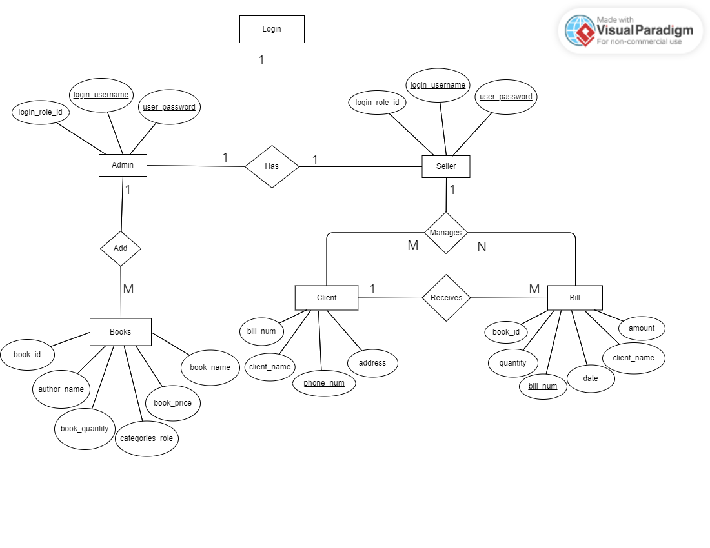

**DATA FLOW DIAGRAM**

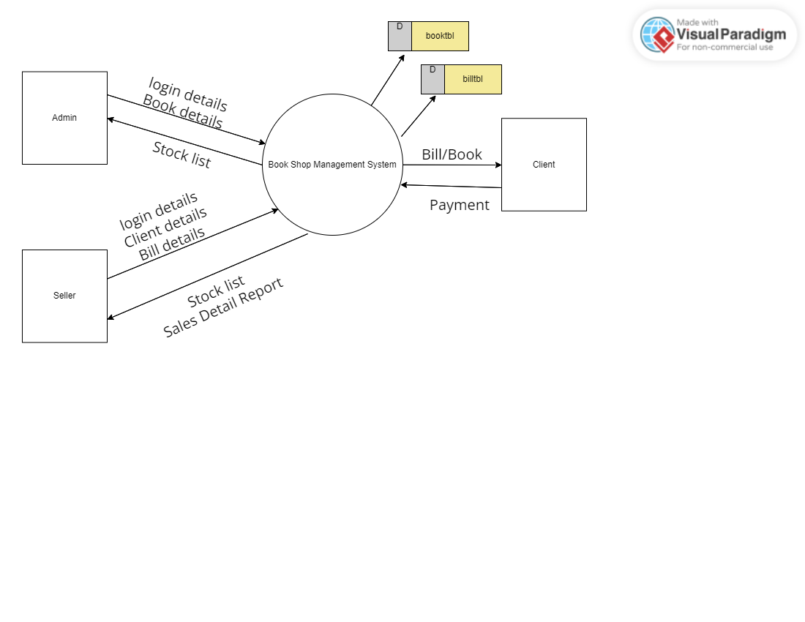**LEVEL 0**

**LEVEL 1**

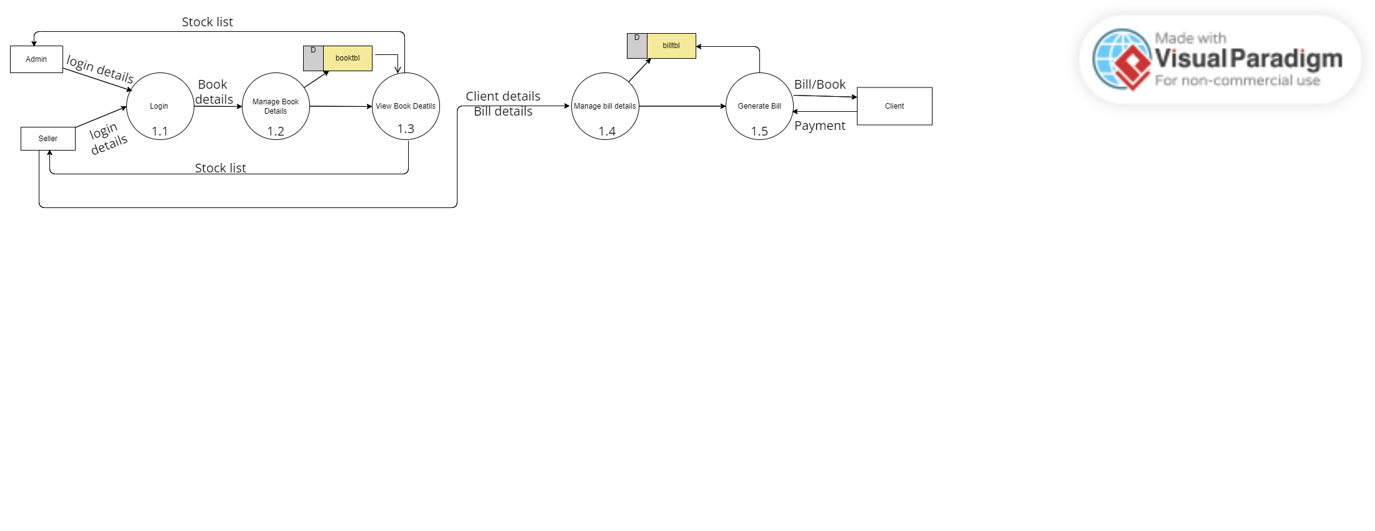

**DATABASE DESIGN**

The data in the system has to be stored and retrieved from database. Designing the database is part of system design. Data elements and data structures to be stored have been identified at analysis stage. They are structured and put together to design the data storage and retrieval system.

A database is a collection of interrelated data stored with minimum redundancy to serve many users quickly and efficiently. The general objective is to make database access easy, quick, inexpensive and flexible for the user. Relationships are established between the data items and unnecessary data items are removed. Normalization is done to get an internal consistency of data and to have minimum redundancy and maximum stability. This ensures minimizing data storage required, minimizing chances of data inconsistencies and optimizing for updates. The MS Access database has been chosen for developing the relevant databases.

**book Sale Management System contains 2 MySQL tables :**

**billtbl :** This table stores bills and clients details

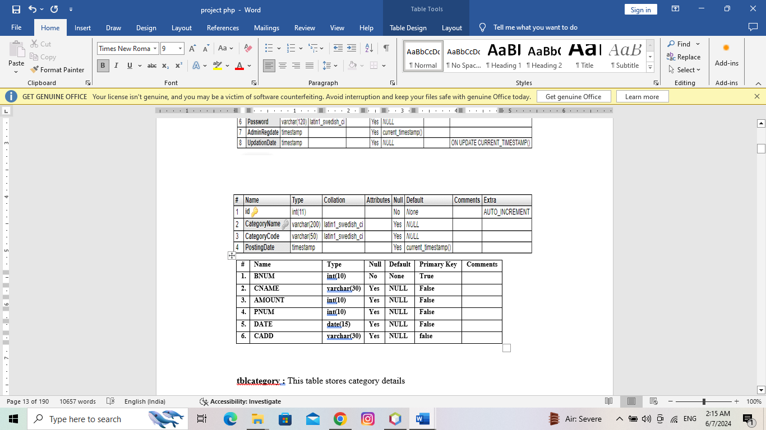

**booktbl :** This table stores books details

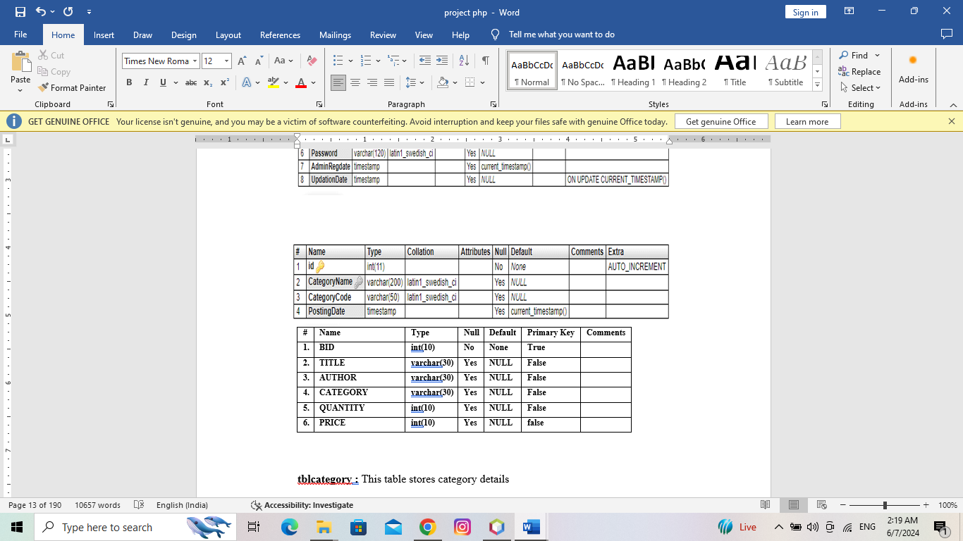

**Program Code**

**login**

package bookshop;

import java.sql.Connection;

import java.sql.DriverManager;

import java.sql.ResultSet;

import java.sql.Statement;

import javax.swing.JOptionPane;

public class Login extends javax.swing.JFrame {

public Login() {

initComponents();

}

private void jLabel1MouseClicked(java.awt.event.MouseEvent evt) {

System.exit(0);

}

private void ResetLblMouseClicked(java.awt.event.MouseEvent evt) {

UnameTb.setText("");

PasswordTb.setText("");

}

Connection Con = null;

Statement St = null;

ResultSet Rs = null;

private void LoginBtnMouseClicked(java.awt.event.MouseEvent evt) {

if(UnameTb.getText().isEmpty() || PasswordTb.getText().isEmpty())

{

JOptionPane.showMessageDialog(this, "Enter the Username and Password");

}else if (RoleCb.getSelectedIndex()==1)

{

//Admin Selected

if(UnameTb.getText().equals("Hitik") && PasswordTb.getText().equals("12345")){

new Billing ().setVisible(true);

this.dispose();

}else{

JOptionPane.showMessageDialog(this, "Contact The admin");

UnameTb.setText("");

PasswordTb.setText("");

}

} else

{

if(UnameTb.getText().equals("Admin") && PasswordTb.getText().equals("Password")){

new Books().setVisible(true);

this.dispose();

}else{

JOptionPane.showMessageDialog(this, "Contact The admin");

UnameTb.setText("");

PasswordTb.setText("");

}

}

}

public static void main(String args[]) {

/* Set the Nimbus look and feel */

//<editor-fold defaultstate="collapsed" desc=" Look and feel setting code (optional) ">

/* If Nimbus (introduced in Java SE 6) is not available, stay with the default look and feel.

* For details see http://download.oracle.com/javase/tutorial/uiswing/lookandfeel/plaf.html

*/

try {

for (javax.swing.UIManager.LookAndFeelInfo info : javax.swing.UIManager.getInstalledLookAndFeels()) {

if ("Nimbus".equals(info.getName())) {

javax.swing.UIManager.setLookAndFeel(info.getClassName());

break;

}

}

} catch (ClassNotFoundException ex) {

java.util.logging.Logger.getLogger(Login.class.getName()).log(java.util.logging.Level.SEVERE, null, ex);

} catch (InstantiationException ex) {

java.util.logging.Logger.getLogger(Login.class.getName()).log(java.util.logging.Level.SEVERE, null, ex);

} catch (IllegalAccessException ex) {

java.util.logging.Logger.getLogger(Login.class.getName()).log(java.util.logging.Level.SEVERE, null, ex);

} catch (javax.swing.UnsupportedLookAndFeelException ex) {

java.util.logging.Logger.getLogger(Login.class.getName()).log(java.util.logging.Level.SEVERE, null, ex);

}

//</editor-fold>

/* Create and display the form */

java.awt.EventQueue.invokeLater(new Runnable() {

public void run() {

new Login().setVisible(true);

}

});

}

private javax.swing.JButton LoginBtn;

private javax.swing.JPasswordField PasswordTb;

private javax.swing.JLabel ResetLbl;

private javax.swing.JComboBox<String> RoleCb;

private javax.swing.JTextField UnameTb;

private javax.swing.JLabel jLabel1;

private javax.swing.JLabel jLabel2;

private javax.swing.JLabel jLabel3;

private javax.swing.JLabel jLabel4;

private javax.swing.JLabel jLabel6;

private javax.swing.JLabel jLabel7;

private javax.swing.JLabel jLabel8;

private javax.swing.JLabel jLabel9;

private javax.swing.JPanel jPanel1;

// End of variables declaration

}

**BOOK FORM**

package bookshop;

import java.sql.Connection;

import java.sql.*;

import javax.swing.JOptionPane;

import javax.swing.table.DefaultTableModel;

import net.proteanit.sql.DbUtils;

public class Books extends javax.swing.JFrame {

public Books() {

initComponents();

DisplayBooks();

}

@SuppressWarnings("unchecked")

// <editor-fold defaultstate="collapsed" desc="Generated Code">

private void initComponents() {

jPanel1 = new javax.swing.JPanel();

jLabel2 = new javax.swing.JLabel();

jLabel1 = new javax.swing.JLabel();

jLabel8 = new javax.swing.JLabel();

DeleteBtn = new javax.swing.JButton();

jLabel9 = new javax.swing.JLabel();

ResetBtn = new javax.swing.JButton();

jLabel10 = new javax.swing.JLabel();

jScrollPane1 = new javax.swing.JScrollPane();

BooksTable = new javax.swing.JTable();

jLabel11 = new javax.swing.JLabel();

BookIdTb = new javax.swing.JTextField();

UserLbl = new javax.swing.JLabel();

NameTb = new javax.swing.JTextField();

jLabel4 = new javax.swing.JLabel();

AuthorTb = new javax.swing.JTextField();

jLabel5 = new javax.swing.JLabel();

jLabel13 = new javax.swing.JLabel();

QuantityTb = new javax.swing.JTextField();

jLabel6 = new javax.swing.JLabel();

PriceTb = new javax.swing.JTextField();

SaveBtn = new javax.swing.JButton();

jLabel7 = new javax.swing.JLabel();

EditBtn = new javax.swing.JButton();

CatCb = new javax.swing.JComboBox<>();

jLabel12 = new javax.swing.JLabel();

LogoutLbl = new javax.swing.JLabel();

PrintBtn = new javax.swing.JButton();

jPanel4 = new javax.swing.JPanel();

setDefaultCloseOperation(javax.swing.WindowConstants.EXIT_ON_CLOSE);

setBackground(new java.awt.Color(255, 255, 255));

setUndecorated(true);

jPanel1.setBackground(new java.awt.Color(255, 255, 255));

jLabel2.setBackground(new java.awt.Color(255, 255, 255));

jLabel2.setFont(new java.awt.Font("Century Gothic", 1, 20)); // NOI18N

jLabel2.setForeground(new java.awt.Color(255, 92, 6));

jLabel2.setText("Book Sale Management System");

jLabel1.setIcon(new javax.swing.ImageIcon(getClass().getResource("/bookshop/icons8-close-window-32.png"))); // NOI18N

jLabel1.addMouseListener(new java.awt.event.MouseAdapter() {

public void mouseClicked(java.awt.event.MouseEvent evt) {

jLabel1MouseClicked(evt);

}

});

javax.swing.GroupLayout jPanel1Layout = new javax.swing.GroupLayout(jPanel1);

jPanel1.setLayout(jPanel1Layout);

jPanel1Layout.setHorizontalGroup(

jPanel1Layout.createParallelGroup(javax.swing.GroupLayout.Alignment.LEADING)

.addGroup(jPanel1Layout.createSequentialGroup()

.addGap(358, 358, 358)

.addComponent(jLabel2, javax.swing.GroupLayout.PREFERRED_SIZE, 318, javax.swing.GroupLayout.PREFERRED_SIZE)

.addPreferredGap(javax.swing.LayoutStyle.ComponentPlacement.RELATED, 319, Short.MAX_VALUE)

.addComponent(jLabel1))

);

jPanel1Layout.setVerticalGroup(

jPanel1Layout.createParallelGroup(javax.swing.GroupLayout.Alignment.LEADING)

.addComponent(jLabel2)

.addComponent(jLabel1)

);

jLabel8.setBackground(new java.awt.Color(255, 255, 255));

jLabel8.setFont(new java.awt.Font("Century Gothic", 0, 16)); // NOI18N

jLabel8.setForeground(new java.awt.Color(255, 92, 6));

jLabel8.setText("Name");

DeleteBtn.setFont(new java.awt.Font("Century Gothic", 0, 20)); // NOI18N

DeleteBtn.setForeground(new java.awt.Color(255, 92, 6));

DeleteBtn.setText("Delete");

DeleteBtn.addMouseListener(new java.awt.event.MouseAdapter() {

public void mouseClicked(java.awt.event.MouseEvent evt) {

DeleteBtnMouseClicked(evt);

}

});

DeleteBtn.addActionListener(new java.awt.event.ActionListener() {

public void actionPerformed(java.awt.event.ActionEvent evt) {

DeleteBtnActionPerformed(evt);

}

});

jLabel9.setBackground(new java.awt.Color(255, 255, 255));

jLabel9.setFont(new java.awt.Font("Century Gothic", 0, 16)); // NOI18N

jLabel9.setForeground(new java.awt.Color(255, 92, 6));

jLabel9.setText("Author");

ResetBtn.setFont(new java.awt.Font("Century Gothic", 0, 20)); // NOI18N

ResetBtn.setForeground(new java.awt.Color(255, 92, 6));

ResetBtn.setText("Reset");

ResetBtn.addMouseListener(new java.awt.event.MouseAdapter() {

public void mouseClicked(java.awt.event.MouseEvent evt) {

ResetBtnMouseClicked(evt);

}

});

ResetBtn.addActionListener(new java.awt.event.ActionListener() {

public void actionPerformed(java.awt.event.ActionEvent evt) {

ResetBtnActionPerformed(evt);

}

});

jLabel10.setBackground(new java.awt.Color(255, 255, 255));

jLabel10.setFont(new java.awt.Font("Century Gothic", 0, 16)); // NOI18N

jLabel10.setForeground(new java.awt.Color(255, 92, 6));

jLabel10.setText("Quantity");

BooksTable.setModel(new javax.swing.table.DefaultTableModel(

new Object [][] {

},

new String [] {

"Id", "Title", "Author", "Categories", "Quantity", "Price"

}

));

BooksTable.setRowHeight(25);

BooksTable.setSelectionBackground(new java.awt.Color(255, 92, 6));

BooksTable.setShowGrid(false);

BooksTable.addMouseListener(new java.awt.event.MouseAdapter() {

public void mouseClicked(java.awt.event.MouseEvent evt) {

BooksTableMouseClicked(evt);

}

});

jScrollPane1.setViewportView(BooksTable);

jLabel11.setBackground(new java.awt.Color(255, 255, 255));

jLabel11.setFont(new java.awt.Font("Century Gothic", 0, 16)); // NOI18N

jLabel11.setForeground(new java.awt.Color(255, 92, 6));

jLabel11.setText("Price");

BookIdTb.setFont(new java.awt.Font("Century Gothic", 0, 14)); // NOI18N

BookIdTb.setForeground(new java.awt.Color(255, 92, 6));

UserLbl.setBackground(new java.awt.Color(255, 255, 255));

UserLbl.setFont(new java.awt.Font("Century Gothic", 0, 18)); // NOI18N

UserLbl.setForeground(new java.awt.Color(255, 92, 6));

UserLbl.setText("Stock");

UserLbl.addMouseListener(new java.awt.event.MouseAdapter() {

public void mouseClicked(java.awt.event.MouseEvent evt) {

UserLblMouseClicked(evt);

}

});

NameTb.setFont(new java.awt.Font("Century Gothic", 0, 14)); // NOI18N

NameTb.setForeground(new java.awt.Color(255, 92, 6));

jLabel4.setIcon(new javax.swing.ImageIcon(getClass().getResource("/bookshop/icons8-user-24.png"))); // NOI18N

AuthorTb.setFont(new java.awt.Font("Century Gothic", 0, 14)); // NOI18N

AuthorTb.setForeground(new java.awt.Color(255, 92, 6));

jLabel5.setBackground(new java.awt.Color(255, 255, 255));

jLabel5.setFont(new java.awt.Font("Century Gothic", 0, 18)); // NOI18N

jLabel5.setForeground(new java.awt.Color(255, 92, 6));

jLabel5.setText("Books");

jLabel13.setBackground(new java.awt.Color(255, 255, 255));

jLabel13.setFont(new java.awt.Font("Century Gothic", 0, 16)); // NOI18N

jLabel13.setForeground(new java.awt.Color(255, 92, 6));

jLabel13.setText("Books Stock");

QuantityTb.setFont(new java.awt.Font("Century Gothic", 0, 14)); // NOI18N

QuantityTb.setForeground(new java.awt.Color(255, 92, 6));

jLabel6.setIcon(new javax.swing.ImageIcon(getClass().getResource("/bookshop/icons8-orange-book-48.png"))); // NOI18N

PriceTb.setFont(new java.awt.Font("Century Gothic", 0, 14)); // NOI18N

PriceTb.setForeground(new java.awt.Color(255, 92, 6));

PriceTb.addActionListener(new java.awt.event.ActionListener() {

public void actionPerformed(java.awt.event.ActionEvent evt) {

PriceTbActionPerformed(evt);

}

});

SaveBtn.setFont(new java.awt.Font("Century Gothic", 0, 20)); // NOI18N

SaveBtn.setForeground(new java.awt.Color(255, 92, 6));

SaveBtn.setText("Save");

SaveBtn.addMouseListener(new java.awt.event.MouseAdapter() {

public void mouseClicked(java.awt.event.MouseEvent evt) {

SaveBtnMouseClicked(evt);

}

});

SaveBtn.addActionListener(new java.awt.event.ActionListener() {

public void actionPerformed(java.awt.event.ActionEvent evt) {

SaveBtnActionPerformed(evt);

}

});

jLabel7.setBackground(new java.awt.Color(255, 255, 255));

jLabel7.setFont(new java.awt.Font("Century Gothic", 0, 16)); // NOI18N

jLabel7.setForeground(new java.awt.Color(255, 92, 6));

jLabel7.setText("Id");

EditBtn.setFont(new java.awt.Font("Century Gothic", 0, 20)); // NOI18N

EditBtn.setForeground(new java.awt.Color(255, 92, 6));

EditBtn.setText("Edit");

EditBtn.addMouseListener(new java.awt.event.MouseAdapter() {

public void mouseClicked(java.awt.event.MouseEvent evt) {

EditBtnMouseClicked(evt);

}

});

EditBtn.addActionListener(new java.awt.event.ActionListener() {

public void actionPerformed(java.awt.event.ActionEvent evt) {

EditBtnActionPerformed(evt);

}

});

CatCb.setFont(new java.awt.Font("Century Gothic", 0, 14)); // NOI18N

CatCb.setForeground(new java.awt.Color(255, 92, 6));

CatCb.setModel(new javax.swing.DefaultComboBoxModel<>(new String[] { "Programming", "Chemistry", "Physics", "Geography", "AutoBiography", "Novels", "Comics" }));

jLabel12.setBackground(new java.awt.Color(255, 255, 255));

jLabel12.setFont(new java.awt.Font("Century Gothic", 0, 16)); // NOI18N

jLabel12.setForeground(new java.awt.Color(255, 92, 6));

jLabel12.setText("Categories");

LogoutLbl.setIcon(new javax.swing.ImageIcon(getClass().getResource("/bookshop/home-16.png"))); // NOI18N

LogoutLbl.addMouseListener(new java.awt.event.MouseAdapter() {

public void mouseClicked(java.awt.event.MouseEvent evt) {

LogoutLblMouseClicked(evt);

}

});

PrintBtn.setFont(new java.awt.Font("Century Gothic", 0, 20)); // NOI18N

PrintBtn.setForeground(new java.awt.Color(255, 92, 6));

PrintBtn.setText("Print");

PrintBtn.addMouseListener(new java.awt.event.MouseAdapter() {

public void mouseClicked(java.awt.event.MouseEvent evt) {

PrintBtnMouseClicked(evt);

}

});

PrintBtn.addActionListener(new java.awt.event.ActionListener() {

public void actionPerformed(java.awt.event.ActionEvent evt) {

PrintBtnActionPerformed(evt);

}

});

jPanel4.setBackground(new java.awt.Color(255, 0, 0));

jPanel4.setPreferredSize(new java.awt.Dimension(72, 2));

javax.swing.GroupLayout jPanel4Layout = new javax.swing.GroupLayout(jPanel4);

jPanel4.setLayout(jPanel4Layout);

jPanel4Layout.setHorizontalGroup(

jPanel4Layout.createParallelGroup(javax.swing.GroupLayout.Alignment.LEADING)

.addGap(0, 72, Short.MAX_VALUE)

);

jPanel4Layout.setVerticalGroup(

jPanel4Layout.createParallelGroup(javax.swing.GroupLayout.Alignment.LEADING)

.addGap(0, 2, Short.MAX_VALUE)

);

javax.swing.GroupLayout layout = new javax.swing.GroupLayout(getContentPane());

getContentPane().setLayout(layout);

layout.setHorizontalGroup(

layout.createParallelGroup(javax.swing.GroupLayout.Alignment.LEADING)

.addComponent(jPanel1, javax.swing.GroupLayout.DEFAULT_SIZE, javax.swing.GroupLayout.DEFAULT_SIZE, Short.MAX_VALUE)

.addGroup(layout.createSequentialGroup()

.addGroup(layout.createParallelGroup(javax.swing.GroupLayout.Alignment.LEADING)

.addGroup(layout.createSequentialGroup()

.addGap(255, 255, 255)

.addComponent(SaveBtn, javax.swing.GroupLayout.PREFERRED_SIZE, 105, javax.swing.GroupLayout.PREFERRED_SIZE)

.addGap(25, 25, 25)

.addComponent(EditBtn, javax.swing.GroupLayout.PREFERRED_SIZE, 105, javax.swing.GroupLayout.PREFERRED_SIZE)

.addGap(25, 25, 25)

.addComponent(DeleteBtn, javax.swing.GroupLayout.PREFERRED_SIZE, 105, javax.swing.GroupLayout.PREFERRED_SIZE)

.addGap(25, 25, 25)

.addComponent(ResetBtn, javax.swing.GroupLayout.PREFERRED_SIZE, 105, javax.swing.GroupLayout.PREFERRED_SIZE))

.addGroup(layout.createSequentialGroup()

.addGap(26, 26, 26)

.addComponent(LogoutLbl)

.addGap(414, 414, 414)

.addComponent(PrintBtn, javax.swing.GroupLayout.PREFERRED_SIZE, 105, javax.swing.GroupLayout.PREFERRED_SIZE)))

.addContainerGap(javax.swing.GroupLayout.DEFAULT_SIZE, Short.MAX_VALUE))

.addGroup(javax.swing.GroupLayout.Alignment.TRAILING, layout.createSequentialGroup()

.addGap(0, 0, Short.MAX_VALUE)

.addComponent(jPanel4, javax.swing.GroupLayout.PREFERRED_SIZE, javax.swing.GroupLayout.DEFAULT_SIZE, javax.swing.GroupLayout.PREFERRED_SIZE)

.addGap(363, 363, 363))

.addGroup(javax.swing.GroupLayout.Alignment.TRAILING, layout.createSequentialGroup()

.addContainerGap(javax.swing.GroupLayout.DEFAULT_SIZE, Short.MAX_VALUE)

.addGroup(layout.createParallelGroup(javax.swing.GroupLayout.Alignment.LEADING)

.addGroup(javax.swing.GroupLayout.Alignment.TRAILING, layout.createSequentialGroup()

.addGroup(layout.createParallelGroup(javax.swing.GroupLayout.Alignment.LEADING)

.addComponent(NameTb, javax.swing.GroupLayout.PREFERRED_SIZE, 157, javax.swing.GroupLayout.PREFERRED_SIZE)

.addComponent(jLabel8))

.addGap(18, 18, 18)

.addGroup(layout.createParallelGroup(javax.swing.GroupLayout.Alignment.LEADING)

.addComponent(AuthorTb, javax.swing.GroupLayout.PREFERRED_SIZE, 160, javax.swing.GroupLayout.PREFERRED_SIZE)

.addComponent(jLabel9))

.addGap(18, 18, 18)

.addGroup(layout.createParallelGroup(javax.swing.GroupLayout.Alignment.LEADING)

.addComponent(CatCb, javax.swing.GroupLayout.PREFERRED_SIZE, 180, javax.swing.GroupLayout.PREFERRED_SIZE)

.addComponent(jLabel12))

.addGap(18, 18, 18)

.addGroup(layout.createParallelGroup(javax.swing.GroupLayout.Alignment.LEADING)

.addComponent(QuantityTb, javax.swing.GroupLayout.PREFERRED_SIZE, 150, javax.swing.GroupLayout.PREFERRED_SIZE)

.addComponent(jLabel10))

.addGap(18, 18, 18)

.addGroup(layout.createParallelGroup(javax.swing.GroupLayout.Alignment.LEADING)

.addComponent(jLabel11)

.addComponent(PriceTb, javax.swing.GroupLayout.PREFERRED_SIZE, 150, javax.swing.GroupLayout.PREFERRED_SIZE))

.addGap(15, 15, 15))

.addGroup(javax.swing.GroupLayout.Alignment.TRAILING, layout.createParallelGroup(javax.swing.GroupLayout.Alignment.LEADING)

.addComponent(jLabel7)

.addComponent(BookIdTb, javax.swing.GroupLayout.PREFERRED_SIZE, 100, javax.swing.GroupLayout.PREFERRED_SIZE)

.addGroup(layout.createParallelGroup(javax.swing.GroupLayout.Alignment.LEADING)

.addGroup(javax.swing.GroupLayout.Alignment.TRAILING, layout.createSequentialGroup()

.addComponent(jLabel13)

.addGap(483, 483, 483))

.addGroup(javax.swing.GroupLayout.Alignment.TRAILING, layout.createSequentialGroup()

.addComponent(jScrollPane1, javax.swing.GroupLayout.PREFERRED_SIZE, 991, javax.swing.GroupLayout.PREFERRED_SIZE)

.addGap(18, 18, 18))))))

.addGroup(layout.createParallelGroup(javax.swing.GroupLayout.Alignment.LEADING)

.addGroup(layout.createSequentialGroup()

.addGap(398, 398, 398)

.addComponent(jLabel4)

.addPreferredGap(javax.swing.LayoutStyle.ComponentPlacement.RELATED)

.addComponent(UserLbl)

.addGap(90, 90, 90)

.addComponent(jLabel6)

.addPreferredGap(javax.swing.LayoutStyle.ComponentPlacement.RELATED)

.addComponent(jLabel5)

.addContainerGap(380, Short.MAX_VALUE)))

);

layout.setVerticalGroup(

layout.createParallelGroup(javax.swing.GroupLayout.Alignment.LEADING)

.addGroup(layout.createSequentialGroup()

.addComponent(jPanel1, javax.swing.GroupLayout.PREFERRED_SIZE, javax.swing.GroupLayout.DEFAULT_SIZE, javax.swing.GroupLayout.PREFERRED_SIZE)

.addGap(33, 33, 33)

.addComponent(jPanel4, javax.swing.GroupLayout.PREFERRED_SIZE, javax.swing.GroupLayout.DEFAULT_SIZE, javax.swing.GroupLayout.PREFERRED_SIZE)

.addGap(8, 8, 8)

.addGroup(layout.createParallelGroup(javax.swing.GroupLayout.Alignment.TRAILING)

.addGroup(layout.createParallelGroup(javax.swing.GroupLayout.Alignment.LEADING)

.addGroup(layout.createParallelGroup(javax.swing.GroupLayout.Alignment.TRAILING)

.addGroup(layout.createParallelGroup(javax.swing.GroupLayout.Alignment.LEADING)

.addComponent(jLabel7)

.addGroup(layout.createSequentialGroup()

.addGap(27, 27, 27)

.addComponent(BookIdTb, javax.swing.GroupLayout.PREFERRED_SIZE, 36, javax.swing.GroupLayout.PREFERRED_SIZE)))

.addGroup(layout.createSequentialGroup()

.addComponent(jLabel9)

.addPreferredGap(javax.swing.LayoutStyle.ComponentPlacement.RELATED)

.addComponent(AuthorTb, javax.swing.GroupLayout.PREFERRED_SIZE, 36, javax.swing.GroupLayout.PREFERRED_SIZE)))

.addGroup(layout.createSequentialGroup()

.addComponent(jLabel12)

.addPreferredGap(javax.swing.LayoutStyle.ComponentPlacement.RELATED)

.addComponent(CatCb, javax.swing.GroupLayout.PREFERRED_SIZE, 36, javax.swing.GroupLayout.PREFERRED_SIZE))

.addGroup(javax.swing.GroupLayout.Alignment.TRAILING, layout.createSequentialGroup()

.addComponent(jLabel10)

.addPreferredGap(javax.swing.LayoutStyle.ComponentPlacement.RELATED)

.addComponent(QuantityTb, javax.swing.GroupLayout.PREFERRED_SIZE, 36, javax.swing.GroupLayout.PREFERRED_SIZE)))

.addGroup(layout.createSequentialGroup()

.addComponent(jLabel11)

.addPreferredGap(javax.swing.LayoutStyle.ComponentPlacement.RELATED)

.addComponent(PriceTb, javax.swing.GroupLayout.PREFERRED_SIZE, 36, javax.swing.GroupLayout.PREFERRED_SIZE))

.addGroup(layout.createSequentialGroup()

.addComponent(jLabel8)

.addPreferredGap(javax.swing.LayoutStyle.ComponentPlacement.RELATED)

.addComponent(NameTb, javax.swing.GroupLayout.PREFERRED_SIZE, 36, javax.swing.GroupLayout.PREFERRED_SIZE)))

.addGap(18, 18, 18)

.addGroup(layout.createParallelGroup(javax.swing.GroupLayout.Alignment.BASELINE)

.addComponent(SaveBtn, javax.swing.GroupLayout.PREFERRED_SIZE, 35, javax.swing.GroupLayout.PREFERRED_SIZE)

.addComponent(EditBtn, javax.swing.GroupLayout.PREFERRED_SIZE, 35, javax.swing.GroupLayout.PREFERRED_SIZE)

.addComponent(DeleteBtn, javax.swing.GroupLayout.PREFERRED_SIZE, 35, javax.swing.GroupLayout.PREFERRED_SIZE)

.addComponent(ResetBtn, javax.swing.GroupLayout.PREFERRED_SIZE, 35, javax.swing.GroupLayout.PREFERRED_SIZE))

.addGap(26, 26, 26)

.addComponent(jLabel13)

.addPreferredGap(javax.swing.LayoutStyle.ComponentPlacement.RELATED)

.addComponent(jScrollPane1, javax.swing.GroupLayout.PREFERRED_SIZE, 312, javax.swing.GroupLayout.PREFERRED_SIZE)

.addPreferredGap(javax.swing.LayoutStyle.ComponentPlacement.UNRELATED)

.addGroup(layout.createParallelGroup(javax.swing.GroupLayout.Alignment.LEADING)

.addComponent(LogoutLbl, javax.swing.GroupLayout.PREFERRED_SIZE, 26, javax.swing.GroupLayout.PREFERRED_SIZE)

.addComponent(PrintBtn))

.addGap(0, 23, Short.MAX_VALUE))

.addGroup(layout.createParallelGroup(javax.swing.GroupLayout.Alignment.LEADING)

.addGroup(layout.createSequentialGroup()

.addGap(39, 39, 39)

.addGroup(layout.createParallelGroup(javax.swing.GroupLayout.Alignment.LEADING)

.addComponent(jLabel5, javax.swing.GroupLayout.Alignment.TRAILING)

.addGroup(javax.swing.GroupLayout.Alignment.TRAILING, layout.createParallelGroup(javax.swing.GroupLayout.Alignment.LEADING)

.addGroup(layout.createParallelGroup(javax.swing.GroupLayout.Alignment.TRAILING)

.addComponent(jLabel4)

.addComponent(UserLbl))

.addComponent(jLabel6)))

.addContainerGap(561, Short.MAX_VALUE)))

);

pack();

setLocationRelativeTo(null);

}// </editor-fold>

private void DeleteBtnActionPerformed(java.awt.event.ActionEvent evt) {

// TODO add your handling code here:

}

private void ResetBtnActionPerformed(java.awt.event.ActionEvent evt) {

// TODO add your handling code here:

}

private void SaveBtnActionPerformed(java.awt.event.ActionEvent evt) {

// TODO add your handling code here:

}

private void EditBtnActionPerformed(java.awt.event.ActionEvent evt) {

// TODO add your handling code here:

}

private void PrintBtnActionPerformed(java.awt.event.ActionEvent evt) {

// TODO add your handling code here:

}

private void PriceTbActionPerformed(java.awt.event.ActionEvent evt) {

// TODO add your handling code here:

}

private void jLabel1MouseClicked(java.awt.event.MouseEvent evt) {

System.exit(0);

}

Connection Con = null;

Statement St = null;

ResultSet Rs = null;

private void DisplayBooks()

{

try {

Con = DriverManager.getConnection("jdbc:derby://localhost:1527/BookShopDb","User1","12345");

St = Con.createStatement();

Rs = St.executeQuery("select * from User1.BookTbl");

BooksTable.setModel(DbUtils.resultSetToTableModel(Rs));

} catch (Exception e) {

}

}

private void Reset()

{

BookIdTb.setText("");

NameTb.setText("");

AuthorTb.setText("");

PriceTb.setText("");

QuantityTb.setText("");

CatCb.setSelectedIndex(0);

}

private void SaveBtnMouseClicked(java.awt.event.MouseEvent evt) {

if(BookIdTb.getText().isEmpty() || NameTb.getText().isEmpty() || AuthorTb.getText().isEmpty() || CatCb.getSelectedIndex() == -1 || QuantityTb.getText().isEmpty() || PriceTb.getText().isEmpty())

{

JOptionPane.showMessageDialog(this,"Missing Information");

}else{

try {

Con = DriverManager.getConnection("jdbc:derby://localhost:1527/BookShopDb","User1","12345");

PreparedStatement add = Con.prepareStatement("insert into BookTbl values(?,?,?,?,?,?)");

add.setInt(1, Integer.valueOf(BookIdTb.getText()));

add.setString(2, NameTb.getText());

add.setString(3, AuthorTb.getText());

add.setString(4, CatCb.getSelectedItem().toString());

add.setInt(5, Integer.valueOf(QuantityTb.getText()));

add.setInt(6, Integer.valueOf(PriceTb.getText()));

int row = add.executeUpdate();

JOptionPane.showMessageDialog(this,"Book Saved");

DisplayBooks();

Reset();

} catch (Exception e) {

e.printStackTrace();

}

}

}

private void ResetBtnMouseClicked(java.awt.event.MouseEvent evt) {

Reset();

}

private void DeleteBtnMouseClicked(java.awt.event.MouseEvent evt) {

if(BookIdTb.getText().isEmpty())

{

JOptionPane.showMessageDialog(this,"Missing Information");

}else{

try {

Con = DriverManager.getConnection("jdbc:derby://localhost:1527/BookShopDb","User1","12345");

String BId = BookIdTb.getText();

String Query = "Delete from User1.BookTbl where BID="+BId;

Statement Delete = Con.createStatement();

Delete.executeUpdate(Query);

JOptionPane.showMessageDialog(this,"Book Deleted");

DisplayBooks();

Reset();

} catch (Exception e) {

e.printStackTrace();

}

}

}

private void BooksTableMouseClicked(java.awt.event.MouseEvent evt) {

DefaultTableModel model = (DefaultTableModel)BooksTable.getModel();

int MyIndex = BooksTable.getSelectedRow();

BookIdTb.setText(model.getValueAt(MyIndex,0).toString());

NameTb.setText(model.getValueAt(MyIndex,1).toString());

AuthorTb.setText(model.getValueAt(MyIndex,2).toString());

CatCb.setSelectedItem(model.getValueAt(MyIndex,3).toString());

QuantityTb.setText(model.getValueAt(MyIndex,4).toString());

PriceTb.setText(model.getValueAt(MyIndex,5).toString());

}

private void EditBtnMouseClicked(java.awt.event.MouseEvent evt) {

if(BookIdTb.getText().isEmpty() || NameTb.getText().isEmpty() || AuthorTb.getText().isEmpty() || CatCb.getSelectedIndex() == -1 || QuantityTb.getText().isEmpty() || PriceTb.getText().isEmpty())

{

JOptionPane.showMessageDialog(this,"Missing Information");

}else{

try {

Con = DriverManager.getConnection("jdbc:derby://localhost:1527/BookShopDb","User1","12345");

String BId = BookIdTb.getText();

String Query = "Update User1.Booktbl set Title='"+NameTb.getText()+"',Author='"+AuthorTb.getText()+"',Category='"+CatCb.getSelectedItem()+"',Quantity="+QuantityTb.getText()+",Price="+PriceTb.getText()+" where BID="+BId;

Statement Delete = Con.createStatement();

Delete.executeUpdate(Query);

JOptionPane.showMessageDialog(this,"Book Updated");

DisplayBooks();

Reset();

} catch (Exception e) {

e.printStackTrace();

}

}

}

private void PrintBtnMouseClicked(java.awt.event.MouseEvent evt) {

try {

BooksTable.print();

} catch (Exception e) {

}

}

private void LogoutLblMouseClicked(java.awt.event.MouseEvent evt) {

new Login().setVisible(true);

this.dispose();

}

private void UserLblMouseClicked(java.awt.event.MouseEvent evt) {

new Users().setVisible(true);

this.dispose();

}

/**

* @param args the command line arguments

*/

public static void main(String args[]) {

/* Set the Nimbus look and feel */

//<editor-fold defaultstate="collapsed" desc=" Look and feel setting code (optional) ">

/* If Nimbus (introduced in Java SE 6) is not available, stay with the default look and feel.

* For details see http://download.oracle.com/javase/tutorial/uiswing/lookandfeel/plaf.html

*/

try {

for (javax.swing.UIManager.LookAndFeelInfo info : javax.swing.UIManager.getInstalledLookAndFeels()) {

if ("Nimbus".equals(info.getName())) {

javax.swing.UIManager.setLookAndFeel(info.getClassName());

break;

}

}

} catch (ClassNotFoundException ex) {

java.util.logging.Logger.getLogger(Books.class.getName()).log(java.util.logging.Level.SEVERE, null, ex);

} catch (InstantiationException ex) {

java.util.logging.Logger.getLogger(Books.class.getName()).log(java.util.logging.Level.SEVERE, null, ex);

} catch (IllegalAccessException ex) {

java.util.logging.Logger.getLogger(Books.class.getName()).log(java.util.logging.Level.SEVERE, null, ex);

} catch (javax.swing.UnsupportedLookAndFeelException ex) {

java.util.logging.Logger.getLogger(Books.class.getName()).log(java.util.logging.Level.SEVERE, null, ex);

}

//</editor-fold>

/* Create and display the form */

java.awt.EventQueue.invokeLater(new Runnable() {

public void run() {

new Books().setVisible(true);

}

});

}

// Variables declaration - do not modify

private javax.swing.JTextField AuthorTb;

private javax.swing.JTextField BookIdTb;

private javax.swing.JTable BooksTable;

private javax.swing.JComboBox<String> CatCb;

private javax.swing.JButton DeleteBtn;

private javax.swing.JButton EditBtn;

private javax.swing.JLabel LogoutLbl;

private javax.swing.JTextField NameTb;

private javax.swing.JTextField PriceTb;

private javax.swing.JButton PrintBtn;

private javax.swing.JTextField QuantityTb;

private javax.swing.JButton ResetBtn;

private javax.swing.JButton SaveBtn;

private javax.swing.JLabel UserLbl;

private javax.swing.JLabel jLabel1;

private javax.swing.JLabel jLabel10;

private javax.swing.JLabel jLabel11;

private javax.swing.JLabel jLabel12;

private javax.swing.JLabel jLabel13;

private javax.swing.JLabel jLabel2;

private javax.swing.JLabel jLabel4;

private javax.swing.JLabel jLabel5;

private javax.swing.JLabel jLabel6;

private javax.swing.JLabel jLabel7;

private javax.swing.JLabel jLabel8;

private javax.swing.JLabel jLabel9;

private javax.swing.JPanel jPanel1;

private javax.swing.JPanel jPanel4;

private javax.swing.JScrollPane jScrollPane1;

// End of variables declaration

}

**STOCK FORM**

package bookshop;

import java.sql.Connection;

import java.sql.DriverManager;

import java.sql.PreparedStatement;

import java.sql.ResultSet;

import java.sql.Statement;

import javax.swing.JOptionPane;

import javax.swing.table.DefaultTableModel;

import net.proteanit.sql.DbUtils;

public class Users extends javax.swing.JFrame {

public Users() {

initComponents();

DisplayBooks();

}

@SuppressWarnings("unchecked")

// <editor-fold defaultstate="collapsed" desc="Generated Code">

private void initComponents() {

jPanel1 = new javax.swing.JPanel();

jLabel2 = new javax.swing.JLabel();

jLabel1 = new javax.swing.JLabel();

jLabel3 = new javax.swing.JLabel();

jLabel4 = new javax.swing.JLabel();

jLabel5 = new javax.swing.JLabel();

jLabel6 = new javax.swing.JLabel();

jPanel2 = new javax.swing.JPanel();

ResetBtn = new javax.swing.JButton();

jScrollPane1 = new javax.swing.JScrollPane();

UsersTable = new javax.swing.JTable();

LogoutLbl = new javax.swing.JLabel();

PrintBtn = new javax.swing.JButton();

jLabel13 = new javax.swing.JLabel();

AuthorTb = new javax.swing.JTextField();

jLabel7 = new javax.swing.JLabel();

jLabel8 = new javax.swing.JLabel();

jLabel9 = new javax.swing.JLabel();

BookIdTb = new javax.swing.JTextField();

NameTb = new javax.swing.JTextField();

SearchBtn = new javax.swing.JButton();

setDefaultCloseOperation(javax.swing.WindowConstants.EXIT_ON_CLOSE);

jPanel1.setBackground(new java.awt.Color(255, 255, 255));

jLabel2.setBackground(new java.awt.Color(255, 255, 255));

jLabel2.setFont(new java.awt.Font("Century Gothic", 1, 20)); // NOI18N

jLabel2.setForeground(new java.awt.Color(255, 92, 6));

jLabel2.setText("Book Sale Management System");

jLabel1.setIcon(new javax.swing.ImageIcon(getClass().getResource("/bookshop/icons8-close-window-32.png"))); // NOI18N

jLabel1.addMouseListener(new java.awt.event.MouseAdapter() {

public void mouseClicked(java.awt.event.MouseEvent evt) {

jLabel1MouseClicked(evt);

}

});

javax.swing.GroupLayout jPanel1Layout = new javax.swing.GroupLayout(jPanel1);

jPanel1.setLayout(jPanel1Layout);

jPanel1Layout.setHorizontalGroup(

jPanel1Layout.createParallelGroup(javax.swing.GroupLayout.Alignment.LEADING)

.addGroup(jPanel1Layout.createSequentialGroup()

.addGap(358, 358, 358)

.addComponent(jLabel2, javax.swing.GroupLayout.PREFERRED_SIZE, 318, javax.swing.GroupLayout.PREFERRED_SIZE)

.addPreferredGap(javax.swing.LayoutStyle.ComponentPlacement.RELATED, javax.swing.GroupLayout.DEFAULT_SIZE, Short.MAX_VALUE)

.addComponent(jLabel1))

);

jPanel1Layout.setVerticalGroup(

jPanel1Layout.createParallelGroup(javax.swing.GroupLayout.Alignment.LEADING)

.addComponent(jLabel2)

.addComponent(jLabel1)

);

jLabel3.setBackground(new java.awt.Color(255, 255, 255));

jLabel3.setFont(new java.awt.Font("Century Gothic", 0, 18)); // NOI18N

jLabel3.setForeground(new java.awt.Color(255, 92, 6));

jLabel3.setText("Stock");

jLabel4.setIcon(new javax.swing.ImageIcon(getClass().getResource("/bookshop/icons8-user-24.png"))); // NOI18N

jLabel5.setBackground(new java.awt.Color(255, 255, 255));

jLabel5.setFont(new java.awt.Font("Century Gothic", 0, 18)); // NOI18N

jLabel5.setForeground(new java.awt.Color(255, 92, 6));

jLabel5.setText("Books");

jLabel5.addMouseListener(new java.awt.event.MouseAdapter() {

public void mouseClicked(java.awt.event.MouseEvent evt) {

jLabel5MouseClicked(evt);

}

});

jLabel6.setIcon(new javax.swing.ImageIcon(getClass().getResource("/bookshop/icons8-orange-book-48.png"))); // NOI18N

jPanel2.setBackground(new java.awt.Color(255, 0, 0));

javax.swing.GroupLayout jPanel2Layout = new javax.swing.GroupLayout(jPanel2);

jPanel2.setLayout(jPanel2Layout);

jPanel2Layout.setHorizontalGroup(

jPanel2Layout.createParallelGroup(javax.swing.GroupLayout.Alignment.LEADING)

.addGap(0, 72, Short.MAX_VALUE)

);

jPanel2Layout.setVerticalGroup(

jPanel2Layout.createParallelGroup(javax.swing.GroupLayout.Alignment.LEADING)

.addGap(0, 2, Short.MAX_VALUE)

);

ResetBtn.setFont(new java.awt.Font("Century Gothic", 0, 20)); // NOI18N

ResetBtn.setForeground(new java.awt.Color(255, 92, 6));

ResetBtn.setText("Reset");

ResetBtn.addMouseListener(new java.awt.event.MouseAdapter() {

public void mouseClicked(java.awt.event.MouseEvent evt) {

ResetBtnMouseClicked(evt);

}

});

ResetBtn.addActionListener(new java.awt.event.ActionListener() {

public void actionPerformed(java.awt.event.ActionEvent evt) {

ResetBtnActionPerformed(evt);

}

});

UsersTable.setModel(new javax.swing.table.DefaultTableModel(

new Object [][] {

},

new String [] {

"Id", "Title", "Author", "Categories", "Quantity", "Price"

}

));

UsersTable.setRowHeight(25);

UsersTable.setSelectionBackground(new java.awt.Color(255, 92, 6));

UsersTable.addMouseListener(new java.awt.event.MouseAdapter() {

public void mouseClicked(java.awt.event.MouseEvent evt) {

UsersTableMouseClicked(evt);

}

});

jScrollPane1.setViewportView(UsersTable);

LogoutLbl.setIcon(new javax.swing.ImageIcon(getClass().getResource("/bookshop/home-16.png"))); // NOI18N

LogoutLbl.addMouseListener(new java.awt.event.MouseAdapter() {

public void mouseClicked(java.awt.event.MouseEvent evt) {

LogoutLblMouseClicked(evt);

}

});

PrintBtn.setFont(new java.awt.Font("Century Gothic", 0, 20)); // NOI18N

PrintBtn.setForeground(new java.awt.Color(255, 92, 6));

PrintBtn.setText("Print");

PrintBtn.addMouseListener(new java.awt.event.MouseAdapter() {

public void mouseClicked(java.awt.event.MouseEvent evt) {

PrintBtnMouseClicked(evt);

}

});

PrintBtn.addActionListener(new java.awt.event.ActionListener() {

public void actionPerformed(java.awt.event.ActionEvent evt) {

PrintBtnActionPerformed(evt);

}

});

jLabel13.setBackground(new java.awt.Color(255, 255, 255));

jLabel13.setFont(new java.awt.Font("Century Gothic", 0, 16)); // NOI18N

jLabel13.setForeground(new java.awt.Color(255, 92, 6));

jLabel13.setText("Books List");

AuthorTb.setFont(new java.awt.Font("Century Gothic", 0, 14)); // NOI18N

AuthorTb.setForeground(new java.awt.Color(255, 92, 6));

jLabel7.setBackground(new java.awt.Color(255, 255, 255));

jLabel7.setFont(new java.awt.Font("Century Gothic", 0, 16)); // NOI18N

jLabel7.setForeground(new java.awt.Color(255, 92, 6));

jLabel7.setText("Id");

jLabel8.setBackground(new java.awt.Color(255, 255, 255));

jLabel8.setFont(new java.awt.Font("Century Gothic", 0, 16)); // NOI18N

jLabel8.setForeground(new java.awt.Color(255, 92, 6));

jLabel8.setText("Name");

jLabel9.setBackground(new java.awt.Color(255, 255, 255));

jLabel9.setFont(new java.awt.Font("Century Gothic", 0, 16)); // NOI18N

jLabel9.setForeground(new java.awt.Color(255, 92, 6));

jLabel9.setText("Author");

BookIdTb.setFont(new java.awt.Font("Century Gothic", 0, 14)); // NOI18N

BookIdTb.setForeground(new java.awt.Color(255, 92, 6));

NameTb.setFont(new java.awt.Font("Century Gothic", 0, 14)); // NOI18N

NameTb.setForeground(new java.awt.Color(255, 92, 6));

SearchBtn.setFont(new java.awt.Font("Century Gothic", 0, 20)); // NOI18N

SearchBtn.setForeground(new java.awt.Color(255, 92, 6));

SearchBtn.setText("Search");

SearchBtn.addMouseListener(new java.awt.event.MouseAdapter() {

public void mouseClicked(java.awt.event.MouseEvent evt) {

SearchBtnMouseClicked(evt);

}

});

SearchBtn.addActionListener(new java.awt.event.ActionListener() {

public void actionPerformed(java.awt.event.ActionEvent evt) {

SearchBtnActionPerformed(evt);

}

});

javax.swing.GroupLayout layout = new javax.swing.GroupLayout(getContentPane());

getContentPane().setLayout(layout);

layout.setHorizontalGroup(

layout.createParallelGroup(javax.swing.GroupLayout.Alignment.LEADING)

.addComponent(jPanel1, javax.swing.GroupLayout.DEFAULT_SIZE, javax.swing.GroupLayout.DEFAULT_SIZE, Short.MAX_VALUE)

.addGroup(layout.createSequentialGroup()

.addGap(36, 36, 36)

.addComponent(LogoutLbl)

.addGap(414, 414, 414)

.addComponent(PrintBtn, javax.swing.GroupLayout.PREFERRED_SIZE, 105, javax.swing.GroupLayout.PREFERRED_SIZE)

.addGap(0, 0, Short.MAX_VALUE))

.addGroup(javax.swing.GroupLayout.Alignment.TRAILING, layout.createSequentialGroup()

.addContainerGap(javax.swing.GroupLayout.DEFAULT_SIZE, Short.MAX_VALUE)

.addGroup(layout.createParallelGroup(javax.swing.GroupLayout.Alignment.LEADING, false)

.addGroup(javax.swing.GroupLayout.Alignment.TRAILING, layout.createSequentialGroup()

.addComponent(jLabel13)

.addGap(471, 471, 471))

.addGroup(javax.swing.GroupLayout.Alignment.TRAILING, layout.createSequentialGroup()

.addComponent(jScrollPane1, javax.swing.GroupLayout.PREFERRED_SIZE, 977, javax.swing.GroupLayout.PREFERRED_SIZE)

.addGap(22, 22, 22))

.addGroup(layout.createSequentialGroup()

.addGap(361, 361, 361)

.addComponent(NameTb, javax.swing.GroupLayout.PREFERRED_SIZE, 157, javax.swing.GroupLayout.PREFERRED_SIZE)

.addGap(106, 106, 106)

.addGroup(layout.createParallelGroup(javax.swing.GroupLayout.Alignment.LEADING)

.addComponent(jLabel9)

.addComponent(AuthorTb, javax.swing.GroupLayout.PREFERRED_SIZE, 160, javax.swing.GroupLayout.PREFERRED_SIZE))

.addContainerGap(221, Short.MAX_VALUE))

.addGroup(javax.swing.GroupLayout.Alignment.TRAILING, layout.createSequentialGroup()

.addComponent(SearchBtn)

.addGap(194, 194, 194)

.addComponent(ResetBtn, javax.swing.GroupLayout.PREFERRED_SIZE, 105, javax.swing.GroupLayout.PREFERRED_SIZE)

.addGap(327, 327, 327))))

.addGroup(layout.createSequentialGroup()

.addGroup(layout.createParallelGroup(javax.swing.GroupLayout.Alignment.TRAILING, false)

.addGroup(layout.createSequentialGroup()

.addGap(395, 395, 395)

.addComponent(jLabel4)

.addPreferredGap(javax.swing.LayoutStyle.ComponentPlacement.RELATED)

.addGroup(layout.createParallelGroup(javax.swing.GroupLayout.Alignment.LEADING)

.addComponent(jPanel2, javax.swing.GroupLayout.PREFERRED_SIZE, javax.swing.GroupLayout.DEFAULT_SIZE, javax.swing.GroupLayout.PREFERRED_SIZE)

.addGroup(layout.createSequentialGroup()

.addComponent(jLabel3)

.addGap(90, 90, 90)

.addComponent(jLabel6)

.addPreferredGap(javax.swing.LayoutStyle.ComponentPlacement.RELATED)

.addComponent(jLabel5))))

.addGroup(javax.swing.GroupLayout.Alignment.LEADING, layout.createSequentialGroup()

.addGap(157, 157, 157)

.addGroup(layout.createParallelGroup(javax.swing.GroupLayout.Alignment.LEADING)

.addComponent(BookIdTb, javax.swing.GroupLayout.PREFERRED_SIZE, 100, javax.swing.GroupLayout.PREFERRED_SIZE)

.addComponent(jLabel7))

.addGap(108, 108, 108)

.addComponent(jLabel8)))

.addContainerGap(javax.swing.GroupLayout.DEFAULT_SIZE, Short.MAX_VALUE))

);

layout.setVerticalGroup(

layout.createParallelGroup(javax.swing.GroupLayout.Alignment.LEADING)

.addGroup(layout.createSequentialGroup()

.addComponent(jPanel1, javax.swing.GroupLayout.PREFERRED_SIZE, javax.swing.GroupLayout.DEFAULT_SIZE, javax.swing.GroupLayout.PREFERRED_SIZE)

.addGap(18, 18, 18)

.addGroup(layout.createParallelGroup(javax.swing.GroupLayout.Alignment.LEADING)

.addComponent(jLabel5, javax.swing.GroupLayout.Alignment.TRAILING)

.addGroup(javax.swing.GroupLayout.Alignment.TRAILING, layout.createParallelGroup(javax.swing.GroupLayout.Alignment.LEADING)

.addGroup(layout.createParallelGroup(javax.swing.GroupLayout.Alignment.TRAILING)

.addComponent(jLabel4)

.addComponent(jLabel3))

.addComponent(jLabel6)))

.addComponent(jPanel2, javax.swing.GroupLayout.PREFERRED_SIZE, javax.swing.GroupLayout.DEFAULT_SIZE, javax.swing.GroupLayout.PREFERRED_SIZE)

.addGap(18, 18, 18)

.addGroup(layout.createParallelGroup(javax.swing.GroupLayout.Alignment.BASELINE)

.addComponent(jLabel8)

.addComponent(jLabel7)

.addComponent(jLabel9))

.addGap(18, 18, 18)

.addGroup(layout.createParallelGroup(javax.swing.GroupLayout.Alignment.BASELINE)

.addComponent(BookIdTb, javax.swing.GroupLayout.PREFERRED_SIZE, 36, javax.swing.GroupLayout.PREFERRED_SIZE)

.addComponent(NameTb, javax.swing.GroupLayout.PREFERRED_SIZE, 36, javax.swing.GroupLayout.PREFERRED_SIZE)

.addComponent(AuthorTb, javax.swing.GroupLayout.PREFERRED_SIZE, 36, javax.swing.GroupLayout.PREFERRED_SIZE))

.addPreferredGap(javax.swing.LayoutStyle.ComponentPlacement.UNRELATED)

.addGroup(layout.createParallelGroup(javax.swing.GroupLayout.Alignment.BASELINE)

.addComponent(ResetBtn, javax.swing.GroupLayout.PREFERRED_SIZE, 35, javax.swing.GroupLayout.PREFERRED_SIZE)

.addComponent(SearchBtn))

.addGap(8, 8, 8)

.addComponent(jLabel13)

.addPreferredGap(javax.swing.LayoutStyle.ComponentPlacement.UNRELATED)

.addComponent(jScrollPane1, javax.swing.GroupLayout.PREFERRED_SIZE, 340, javax.swing.GroupLayout.PREFERRED_SIZE)

.addGap(5, 5, 5)

.addGroup(layout.createParallelGroup(javax.swing.GroupLayout.Alignment.LEADING)

.addComponent(LogoutLbl, javax.swing.GroupLayout.PREFERRED_SIZE, 26, javax.swing.GroupLayout.PREFERRED_SIZE)

.addComponent(PrintBtn))

.addContainerGap(javax.swing.GroupLayout.DEFAULT_SIZE, Short.MAX_VALUE))

);

pack();

}// </editor-fold>

private void PrintBtnActionPerformed(java.awt.event.ActionEvent evt) {

// TODO add your handling code here:

}

Connection Con = null;

Statement St = null;

ResultSet Rs = null;

private void DisplayBooks()

{

try {

Con = DriverManager.getConnection("jdbc:derby://localhost:1527/BookShopDb","User1","12345");

St = Con.createStatement();

Rs = St.executeQuery("select * from User1.BookTbl");

UsersTable.setModel(DbUtils.resultSetToTableModel(Rs));

} catch (Exception e) {

}

}

private void Reset()

{

BookIdTb.setText("");

NameTb.setText("");

AuthorTb.setText("");

}

private void LogoutLblMouseClicked(java.awt.event.MouseEvent evt) {

new Login().setVisible(true);

this.dispose();

}

private void PrintBtnMouseClicked(java.awt.event.MouseEvent evt) {

try{

UsersTable.print();

} catch (Exception e) {

}

}

private void jLabel1MouseClicked(java.awt.event.MouseEvent evt) {

System.exit(0);

}

private void jLabel5MouseClicked(java.awt.event.MouseEvent evt) {

new Books().setVisible(true);

this.dispose();

}

private void ResetBtnActionPerformed(java.awt.event.ActionEvent evt) {

// TODO add your handling code here:

}

private void ResetBtnMouseClicked(java.awt.event.MouseEvent evt) {

Reset();

}

private void UsersTableMouseClicked(java.awt.event.MouseEvent evt) {

}

private void SearchBtnMouseClicked(java.awt.event.MouseEvent evt) {

searchBooks();

}

private void searchBooks() {

if(BookIdTb.getText().isEmpty() && NameTb.getText().isEmpty() && AuthorTb.getText().isEmpty())

{

JOptionPane.showMessageDialog(this,"Missing Information");

}

String query = "SELECT * FROM User1.BookTbl WHERE 1=1";

if (!BookIdTb.getText().isEmpty()) {

query += " AND BID = " + BookIdTb.getText();

}

if (!NameTb.getText().isEmpty()) {

query += " AND Title LIKE '%" + NameTb.getText() + "%'";

}

if (!AuthorTb.getText().isEmpty()) {

query += " AND Author LIKE '%" + AuthorTb.getText() + "%'";

}

try {

Con = DriverManager.getConnection("jdbc:derby://localhost:1527/BookShopDb", "User1", "12345");

St = Con.createStatement();

Rs = St.executeQuery(query);

UsersTable.setModel(DbUtils.resultSetToTableModel(Rs));

} catch (Exception e) {

e.printStackTrace();

}

}

private void SearchBtnActionPerformed(java.awt.event.ActionEvent evt) {

// TODO add your handling code here:

}

/**

* @param args the command line arguments

*/

public static void main(String args[]) {

/* Set the Nimbus look and feel */

//<editor-fold defaultstate="collapsed" desc=" Look and feel setting code (optional) ">

/* If Nimbus (introduced in Java SE 6) is not available, stay with the default look and feel.

* For details see http://download.oracle.com/javase/tutorial/uiswing/lookandfeel/plaf.html

*/

try {

for (javax.swing.UIManager.LookAndFeelInfo info : javax.swing.UIManager.getInstalledLookAndFeels()) {

if ("Nimbus".equals(info.getName())) {

javax.swing.UIManager.setLookAndFeel(info.getClassName());

break;

}

}

} catch (ClassNotFoundException ex) {

java.util.logging.Logger.getLogger(Users.class.getName()).log(java.util.logging.Level.SEVERE, null, ex);

} catch (InstantiationException ex) {

java.util.logging.Logger.getLogger(Users.class.getName()).log(java.util.logging.Level.SEVERE, null, ex);

} catch (IllegalAccessException ex) {

java.util.logging.Logger.getLogger(Users.class.getName()).log(java.util.logging.Level.SEVERE, null, ex);

} catch (javax.swing.UnsupportedLookAndFeelException ex) {

java.util.logging.Logger.getLogger(Users.class.getName()).log(java.util.logging.Level.SEVERE, null, ex);

}

//</editor-fold>

/* Create and display the form */

java.awt.EventQueue.invokeLater(new Runnable() {

public void run() {

new Users().setVisible(true);

}

});

}

// Variables declaration - do not modify

private javax.swing.JTextField AuthorTb;

private javax.swing.JTextField BookIdTb;

private javax.swing.JLabel LogoutLbl;

private javax.swing.JTextField NameTb;

private javax.swing.JButton PrintBtn;

private javax.swing.JButton ResetBtn;

private javax.swing.JButton SearchBtn;

private javax.swing.JTable UsersTable;

private javax.swing.JLabel jLabel1;

private javax.swing.JLabel jLabel13;

private javax.swing.JLabel jLabel2;

private javax.swing.JLabel jLabel3;

private javax.swing.JLabel jLabel4;

private javax.swing.JLabel jLabel5;

private javax.swing.JLabel jLabel6;

private javax.swing.JLabel jLabel7;

private javax.swing.JLabel jLabel8;

private javax.swing.JLabel jLabel9;

private javax.swing.JPanel jPanel1;

private javax.swing.JPanel jPanel2;

private javax.swing.JScrollPane jScrollPane1;

// End of variables declaration

}

**BILLING FORM**

package bookshop;

import java.sql.Connection;

import java.sql.DriverManager;

import java.sql.PreparedStatement;

import java.sql.ResultSet;

import java.sql.Statement;

import java.text.SimpleDateFormat;

import javax.swing.JOptionPane;

import javax.swing.table.DefaultTableModel;

import net.proteanit.sql.DbUtils;

import java.util.Date;

import java.text.ParseException;

public class Billing extends javax.swing.JFrame {

public Billing() {

initComponents();

DisplayBooks();

CountRow();

BillNumTb.setEditable(false);

BookNameTb.setEditable(false);

PriceTb.setEditable(false);

}

Connection Con = null;

Statement St = null, St1 =null;

ResultSet Rs = null, Rs1 = null;

private void DisplayBooks()

{

try {

Con = DriverManager.getConnection("jdbc:derby://localhost:1527/BookShopDb","User1","12345");

St = Con.createStatement();

Rs = St.executeQuery("select * from User1.BookTbl");

BooksTable.setModel(DbUtils.resultSetToTableModel(Rs));

} catch (Exception e) {

}

}

int Stock = 0;

private void BooksTableMouseClicked(java.awt.event.MouseEvent evt) {

DefaultTableModel model = (DefaultTableModel)BooksTable.getModel();

int MyIndex = BooksTable.getSelectedRow();

BId = Integer.valueOf(model.getValueAt(MyIndex,0).toString());

BookNameTb.setText(model.getValueAt(MyIndex,1).toString());

Stock = Integer.valueOf(model.getValueAt(MyIndex,4).toString());

PriceTb.setText(model.getValueAt(MyIndex,5).toString());

}

private boolean isValidDate(String dateStr) {

SimpleDateFormat sdf = new SimpleDateFormat("yyyy-MM-dd");

sdf.setLenient(false);

try {

Date date = sdf.parse(dateStr);

return true;

} catch (ParseException e) {

return false;

}

}

private void SaveBill()

{

String phoneNumber = Ph.getText();

String dateStr = DateTb.getText();

if(BillNumTb.getText().isEmpty() || ClientNameTb.getText().isEmpty() || Ph.getText().isEmpty()|| dateStr.isEmpty() || Cadd.getText().isEmpty())

{

JOptionPane.showMessageDialog(this,"Missing Information");

}

else if (!isValidPhoneNumber(phoneNumber)) {

JOptionPane.showMessageDialog(this, "Invalid Phone Number");

}

else if (!isValidDate(dateStr)) {

JOptionPane.showMessageDialog(this, "Invalid Date. Use format yyyy-MM-dd");

}

else{

try {

Con = DriverManager.getConnection("jdbc:derby://localhost:1527/BookShopDb","User1","12345");

PreparedStatement add = Con.prepareStatement("insert into BillTbl values(?,?,?,?,?,?)");

add.setInt(1, Integer.valueOf(BillNumTb.getText()));

add.setString(2, ClientNameTb.getText());

add.setInt(3, Integer.valueOf(Total));

add.setString(4, phoneNumber);

add.setString(5, dateStr);

add.setString(6, Cadd.getText());

int row = add.executeUpdate();

JOptionPane.showMessageDialog(this,"Bill Saved");

} catch (Exception e) {

e.printStackTrace();

}

}

}

private boolean isValidPhoneNumber(String phoneNumber) {

// Check if the phone number is between 10 and 15 digits and contains only digits

return phoneNumber.matches("\\d{10}");

}

private void Reset ()

{

BookNameTb.setText("");

PriceTb.setText("");

QtyTb.setText("");

Ph.setText("");

DateTb.setText("");

ClientNameTb.setText("");

Cadd.setText("");

BillTxt.setText("");

i = 0;

GrdTotalLbl.setText("Total");

}

int BId;

private void UpdateBook() {

int newQty = Stock - Integer.valueOf(QtyTb.getText());

try {

Con = DriverManager.getConnection("jdbc:derby://localhost:1527/BookShopDb","User1","12345");

String Query = "Update User1.Booktbl set Quantity="+newQty+" where BID="+BId;

Statement Delete = Con.createStatement();

Delete.executeUpdate(Query);

JOptionPane.showMessageDialog(this,"Book Updated");

DisplayBooks();

//Reset();

} catch (Exception e) {

e.printStackTrace();

}

}

int i = 0, Total=0, GrdTotal=0;

private void AddToBilBtnMouseClicked(java.awt.event.MouseEvent evt) {

String phoneNumber = Ph.getText();

String dateStr = DateTb.getText();

if(QtyTb.getText().isEmpty() || BookNameTb.getText().isEmpty() || BillNumTb.getText().isEmpty() || ClientNameTb.getText().isEmpty() || Ph.getText().isEmpty() || dateStr.isEmpty() || Cadd.getText().isEmpty())

{

JOptionPane.showMessageDialog(this,"Missing Informatiom");

}else if (!isValidPhoneNumber(phoneNumber)) {

JOptionPane.showMessageDialog(this, "Invalid Phone Number");

}

else if (!isValidDate(dateStr)) {

JOptionPane.showMessageDialog(this, "Invalid Date. Use format yyyy-MM-dd");

}

else if(Integer.valueOf(QtyTb.getText())> Stock)

{

JOptionPane.showMessageDialog(this,"No Enough Books In Stock");

}else{

i++;

Total = Integer.valueOf(PriceTb.getText())*Integer.valueOf(QtyTb.getText());

if(i == 1)

{

BillTxt.setText(BillTxt.getText()+" ===================BOOK SHOP==================\n"+" NUM PRODUCT PRICE QUANTITY TOTAL PHONE DATE\n"+i+" "+BookNameTb.getText()+" "+PriceTb.getText()+" "+QtyTb.getText()+" "+Total+" "+Ph.getText()+" "+DateTb.getText()+"\n");

}else{

BillTxt.setText(BillTxt.getText()+i+" "+BookNameTb.getText()+" "+PriceTb.getText()+" "+QtyTb.getText()+" "+Total+" "+Ph.getText()+" "+DateTb.getText()+"\n");

}

GrdTotal = GrdTotal + Total;

GrdTotalLbl.setText("Rs "+GrdTotal);

UpdateBook();

}

private void CountRow()

{

try {

Con = DriverManager.getConnection("jdbc:derby://localhost:1527/BookShopDb","User1","12345");

St1 = Con.createStatement();

Rs1 = St1.executeQuery("select * from User1.BILLTBL order by BNUM DESC FETCH FIRST ROW ONLY");

Rs1.next();

int Id = Rs1.getInt(1)+1;

BillNumTb.setText(Id+"");

} catch (Exception e){

e.printStackTrace();

}

}

private void PrintBtnMouseClicked(java.awt.event.MouseEvent evt) {

try {

BillTxt.print();

} catch (Exception e) {

}

SaveBill();

CountRow();

Reset();

}

private void ResetBtnMouseClicked(java.awt.event.MouseEvent evt) {

Reset();

}

private void jLabel1MouseClicked(java.awt.event.MouseEvent evt) {

System.exit(0);

}

private void jLabel17MouseClicked(java.awt.event.MouseEvent evt) {

new Login().setVisible(true);

this.dispose();

}

private void BillNumTbActionPerformed(java.awt.event.ActionEvent evt) {

// TODO add your handling code here:

}

private void BillNumTbMouseClicked(java.awt.event.MouseEvent evt) {

// TODO add your handling code here:

}

private void jLabel5MouseClicked(java.awt.event.MouseEvent evt) {

new Sale().setVisible(true);

this.dispose();

}

private void UnameLbl1MouseClicked(java.awt.event.MouseEvent evt) {

new Client().setVisible(true);

this.dispose();

}

/**

* @param args the command line arguments

*/

public static void main(String args[]) {

/* Set the Nimbus look and feel */

//<editor-fold defaultstate="collapsed" desc=" Look and feel setting code (optional) ">

/* If Nimbus (introduced in Java SE 6) is not available, stay with the default look and feel.

* For details see http://download.oracle.com/javase/tutorial/uiswing/lookandfeel/plaf.html

*/

try {

for (javax.swing.UIManager.LookAndFeelInfo info : javax.swing.UIManager.getInstalledLookAndFeels()) {

if ("Nimbus".equals(info.getName())) {

javax.swing.UIManager.setLookAndFeel(info.getClassName());

break;

}

}

} catch (ClassNotFoundException ex) {

java.util.logging.Logger.getLogger(Billing.class.getName()).log(java.util.logging.Level.SEVERE, null, ex);

} catch (InstantiationException ex) {

java.util.logging.Logger.getLogger(Billing.class.getName()).log(java.util.logging.Level.SEVERE, null, ex);

} catch (IllegalAccessException ex) {

java.util.logging.Logger.getLogger(Billing.class.getName()).log(java.util.logging.Level.SEVERE, null, ex);

} catch (javax.swing.UnsupportedLookAndFeelException ex) {

java.util.logging.Logger.getLogger(Billing.class.getName()).log(java.util.logging.Level.SEVERE, null, ex);

}

//</editor-fold>

/* Create and display the form */

java.awt.EventQueue.invokeLater(new Runnable() {

public void run() {

new Billing().setVisible(true);

}

});

}

**SALE FORM**

package bookshop;

import javax.swing.*;

import java.awt.event.ActionEvent;

import java.awt.event.ActionListener;

import java.sql.Connection;

import java.sql.DriverManager;

import java.sql.PreparedStatement;

import java.sql.ResultSet;

import java.sql.Statement;

import java.text.ParseException;

import java.text.SimpleDateFormat;

import java.util.Date;

import net.proteanit.sql.DbUtils;

public class Sale extends javax.swing.JFrame {

public Sale() {

initComponents();

DisplaySale();

resultLabel.setEditable(false);

}

Connection Con = null;

Statement St = null;

ResultSet Rs = null;

private void DisplaySale()

{

try {

Con = DriverManager.getConnection("jdbc:derby://localhost:1527/BookShopDb","User1","12345");

St = Con.createStatement();

Rs = St.executeQuery("select BNUM,CNAME,AMOUNT,DATE from User1.BillTbl");

SaleTbl.setModel(DbUtils.resultSetToTableModel(Rs));

} catch (Exception e) {

}

}

private boolean isValidDate(String dateStr) {

SimpleDateFormat sdf = new SimpleDateFormat("yyyy-MM-dd");

sdf.setLenient(false);

try {

Date date = sdf.parse(dateStr);

return true;

} catch (ParseException e) {

return false;

}

}

private void calculateTotalSales() {

String startDate = startDateField.getText();

String endDate = endDateField.getText();

if (!isValidDate(startDate) || !isValidDate(endDate)) {

JOptionPane.showMessageDialog(this, "Invalid Date. Use format yyyy-MM-dd");

return;

}

Connection Con = null;

try {

Con = DriverManager.getConnection("jdbc:derby://localhost:1527/BookShopDb", "User1", "12345");

String query = "SELECT SUM(Amount) FROM BillTbl WHERE Date BETWEEN ? AND ?";

PreparedStatement ps = Con.prepareStatement(query);

ps.setString(1, startDate);

ps.setString(2, endDate);

ResultSet rs = ps.executeQuery();

if (rs.next()) {

int totalSales = rs.getInt(1);

resultLabel.setText(""+totalSales);

} else {

resultLabel.setText("0");

String query1 = "SELECT BNUM,CNAME,AMOUNT,DATE FROM User1.BillTbl WHERE Date BETWEEN ? AND ?";

PreparedStatement ps1 = Con.prepareStatement(query1);

ps1.setString(1, startDate);

ps1.setString(2, endDate);

rs = ps1.executeQuery();

SaleTbl.setModel(DbUtils.resultSetToTableModel(rs));

} catch (Exception e) {

e.printStackTrace();

}

}

// <editor-fold defaultstate="collapsed" desc="Generated Code">

private void initComponents() {

LogoutLbl = new javax.swing.JLabel();

PrintBtn = new javax.swing.JButton();

jLabel13 = new javax.swing.JLabel();

resultLabel = new javax.swing.JTextField();

jLabel7 = new javax.swing.JLabel();

jLabel8 = new javax.swing.JLabel();

jLabel9 = new javax.swing.JLabel();

startDateField = new javax.swing.JTextField();

ResetBtn = new javax.swing.JButton();

endDateField = new javax.swing.JTextField();

jScrollPane1 = new javax.swing.JScrollPane();

SaleTbl = new javax.swing.JTable();

calculateButton = new javax.swing.JButton();

jPanel1 = new javax.swing.JPanel();

jLabel2 = new javax.swing.JLabel();

jLabel1 = new javax.swing.JLabel();

UnameLbl = new javax.swing.JLabel();

jLabel4 = new javax.swing.JLabel();

jLabel5 = new javax.swing.JLabel();

jLabel6 = new javax.swing.JLabel();

jPanel4 = new javax.swing.JPanel();

UnameLbl1 = new javax.swing.JLabel();

jLabel10 = new javax.swing.JLabel();

setDefaultCloseOperation(javax.swing.WindowConstants.EXIT_ON_CLOSE);

LogoutLbl.setIcon(new javax.swing.ImageIcon(getClass().getResource("/bookshop/home-16.png"))); // NOI18N

LogoutLbl.addMouseListener(new java.awt.event.MouseAdapter() {

public void mouseClicked(java.awt.event.MouseEvent evt) {

LogoutLblMouseClicked(evt);

}

});

PrintBtn.setFont(new java.awt.Font("Century Gothic", 0, 20)); // NOI18N

PrintBtn.setForeground(new java.awt.Color(255, 92, 6));

PrintBtn.setText("Print");

PrintBtn.addMouseListener(new java.awt.event.MouseAdapter() {

public void mouseClicked(java.awt.event.MouseEvent evt) {

PrintBtnMouseClicked(evt);

}

});

PrintBtn.addActionListener(new java.awt.event.ActionListener() {

public void actionPerformed(java.awt.event.ActionEvent evt) {

PrintBtnActionPerformed(evt);

}

});

jLabel13.setBackground(new java.awt.Color(255, 255, 255));

jLabel13.setFont(new java.awt.Font("Century Gothic", 0, 16)); // NOI18N

jLabel13.setForeground(new java.awt.Color(255, 92, 6));

jLabel13.setText("Books Sale");

resultLabel.setFont(new java.awt.Font("Century Gothic", 0, 14)); // NOI18N

resultLabel.setForeground(new java.awt.Color(255, 92, 6));

jLabel7.setBackground(new java.awt.Color(255, 255, 255));

jLabel7.setFont(new java.awt.Font("Century Gothic", 0, 16)); // NOI18N

jLabel7.setForeground(new java.awt.Color(255, 92, 6));

jLabel7.setText("Start Date");

jLabel8.setBackground(new java.awt.Color(255, 255, 255));

jLabel8.setFont(new java.awt.Font("Century Gothic", 0, 16)); // NOI18N

jLabel8.setForeground(new java.awt.Color(255, 92, 6));

jLabel8.setText("End Date");

jLabel9.setBackground(new java.awt.Color(255, 255, 255));

jLabel9.setFont(new java.awt.Font("Century Gothic", 0, 16)); // NOI18N

jLabel9.setForeground(new java.awt.Color(255, 92, 6));

jLabel9.setText("Total Sale");

startDateField.setFont(new java.awt.Font("Century Gothic", 0, 14)); // NOI18N

startDateField.setForeground(new java.awt.Color(255, 92, 6));

ResetBtn.setFont(new java.awt.Font("Century Gothic", 0, 20)); // NOI18N

ResetBtn.setForeground(new java.awt.Color(255, 92, 6));

ResetBtn.setText("Reset");

ResetBtn.addMouseListener(new java.awt.event.MouseAdapter() {

public void mouseClicked(java.awt.event.MouseEvent evt) {

ResetBtnMouseClicked(evt);

}

});

ResetBtn.addActionListener(new java.awt.event.ActionListener() {

public void actionPerformed(java.awt.event.ActionEvent evt) {

ResetBtnActionPerformed(evt);

}

});

endDateField.setFont(new java.awt.Font("Century Gothic", 0, 14)); // NOI18N

endDateField.setForeground(new java.awt.Color(255, 92, 6));

SaleTbl.setModel(new javax.swing.table.DefaultTableModel(

new Object [][] {

},

new String [] {

"Bill Num", "Client Name", "Amount", "Date"

}

));

SaleTbl.setRowHeight(25);

SaleTbl.setSelectionBackground(new java.awt.Color(255, 92, 6));

SaleTbl.addMouseListener(new java.awt.event.MouseAdapter() {

public void mouseClicked(java.awt.event.MouseEvent evt) {

SaleTblMouseClicked(evt);

}

});

jScrollPane1.setViewportView(SaleTbl);

calculateButton.setFont(new java.awt.Font("Century Gothic", 0, 20)); // NOI18N

calculateButton.setForeground(new java.awt.Color(255, 92, 6));

calculateButton.setText("Search");

calculateButton.addMouseListener(new java.awt.event.MouseAdapter() {

public void mouseClicked(java.awt.event.MouseEvent evt) {

calculateButtonMouseClicked(evt);

}

});

calculateButton.addActionListener(new java.awt.event.ActionListener() {

public void actionPerformed(java.awt.event.ActionEvent evt) {

calculateButtonActionPerformed(evt);

}

});

jPanel1.setBackground(new java.awt.Color(255, 255, 255));

jLabel2.setBackground(new java.awt.Color(255, 255, 255));

jLabel2.setFont(new java.awt.Font("Century Gothic", 1, 20)); // NOI18N

jLabel2.setForeground(new java.awt.Color(255, 92, 6));

jLabel2.setText("Book Sale Management System");

jLabel1.setIcon(new javax.swing.ImageIcon(getClass().getResource("/bookshop/icons8-close-window-32.png"))); // NOI18N

jLabel1.addMouseListener(new java.awt.event.MouseAdapter() {

public void mouseClicked(java.awt.event.MouseEvent evt) {

jLabel1MouseClicked(evt);

}

});

javax.swing.GroupLayout jPanel1Layout = new javax.swing.GroupLayout(jPanel1);

jPanel1.setLayout(jPanel1Layout);

jPanel1Layout.setHorizontalGroup(

jPanel1Layout.createParallelGroup(javax.swing.GroupLayout.Alignment.LEADING)

.addGroup(jPanel1Layout.createSequentialGroup()

.addGap(358, 358, 358)

.addComponent(jLabel2, javax.swing.GroupLayout.PREFERRED_SIZE, 318, javax.swing.GroupLayout.PREFERRED_SIZE)

.addPreferredGap(javax.swing.LayoutStyle.ComponentPlacement.RELATED, javax.swing.GroupLayout.DEFAULT_SIZE, Short.MAX_VALUE)

.addComponent(jLabel1))

);

jPanel1Layout.setVerticalGroup(

jPanel1Layout.createParallelGroup(javax.swing.GroupLayout.Alignment.LEADING)

.addComponent(jLabel2)

.addComponent(jLabel1)

);

UnameLbl.setBackground(new java.awt.Color(255, 255, 255));

UnameLbl.setFont(new java.awt.Font("Century Gothic", 0, 18)); // NOI18N

UnameLbl.setForeground(new java.awt.Color(255, 92, 6));

UnameLbl.setText("Seller");

UnameLbl.addMouseListener(new java.awt.event.MouseAdapter() {

public void mouseClicked(java.awt.event.MouseEvent evt) {

UnameLblMouseClicked(evt);

}

});

jLabel4.setIcon(new javax.swing.ImageIcon(getClass().getResource("/bookshop/icons8-user-24.png"))); // NOI18N

jLabel5.setBackground(new java.awt.Color(255, 255, 255));

jLabel5.setFont(new java.awt.Font("Century Gothic", 0, 18)); // NOI18N

jLabel5.setForeground(new java.awt.Color(255, 92, 6));

jLabel5.setText("Sale");

jLabel6.setIcon(new javax.swing.ImageIcon(getClass().getResource("/bookshop/icons8-orange-book-48.png"))); // NOI18N

jPanel4.setBackground(new java.awt.Color(255, 0, 0));

jPanel4.setPreferredSize(new java.awt.Dimension(72, 2));

javax.swing.GroupLayout jPanel4Layout = new javax.swing.GroupLayout(jPanel4);

jPanel4.setLayout(jPanel4Layout);

jPanel4Layout.setHorizontalGroup(

jPanel4Layout.createParallelGroup(javax.swing.GroupLayout.Alignment.LEADING)

.addGap(0, 72, Short.MAX_VALUE)

);

jPanel4Layout.setVerticalGroup(

jPanel4Layout.createParallelGroup(javax.swing.GroupLayout.Alignment.LEADING)

.addGap(0, 2, Short.MAX_VALUE)

);

UnameLbl1.setBackground(new java.awt.Color(255, 255, 255));

UnameLbl1.setFont(new java.awt.Font("Century Gothic", 0, 18)); // NOI18N

UnameLbl1.setForeground(new java.awt.Color(255, 92, 6));

UnameLbl1.setText("Client Info");

UnameLbl1.addMouseListener(new java.awt.event.MouseAdapter() {

public void mouseClicked(java.awt.event.MouseEvent evt) {

UnameLbl1MouseClicked(evt);

}

});

jLabel10.setIcon(new javax.swing.ImageIcon(getClass().getResource("/bookshop/icons8-user-24.png"))); // NOI18N

javax.swing.GroupLayout layout = new javax.swing.GroupLayout(getContentPane());

getContentPane().setLayout(layout);

layout.setHorizontalGroup(

layout.createParallelGroup(javax.swing.GroupLayout.Alignment.LEADING)

.addComponent(jPanel1, javax.swing.GroupLayout.DEFAULT_SIZE, javax.swing.GroupLayout.DEFAULT_SIZE, Short.MAX_VALUE)

.addGroup(javax.swing.GroupLayout.Alignment.TRAILING, layout.createSequentialGroup()

.addContainerGap(javax.swing.GroupLayout.DEFAULT_SIZE, Short.MAX_VALUE)

.addGroup(layout.createParallelGroup(javax.swing.GroupLayout.Alignment.LEADING)

.addGroup(javax.swing.GroupLayout.Alignment.TRAILING, layout.createSequentialGroup()

.addComponent(calculateButton)

.addGap(199, 199, 199)

.addComponent(ResetBtn, javax.swing.GroupLayout.PREFERRED_SIZE, 105, javax.swing.GroupLayout.PREFERRED_SIZE)

.addGap(338, 338, 338))

.addGroup(javax.swing.GroupLayout.Alignment.TRAILING, layout.createSequentialGroup()

.addComponent(startDateField, javax.swing.GroupLayout.PREFERRED_SIZE, 155, javax.swing.GroupLayout.PREFERRED_SIZE)

.addGap(708, 708, 708))

.addGroup(javax.swing.GroupLayout.Alignment.TRAILING, layout.createSequentialGroup()

.addComponent(jLabel13)

.addGap(471, 471, 471))))

.addGroup(layout.createSequentialGroup()

.addGap(36, 36, 36)

.addGroup(layout.createParallelGroup(javax.swing.GroupLayout.Alignment.LEADING)

.addComponent(jScrollPane1, javax.swing.GroupLayout.PREFERRED_SIZE, 977, javax.swing.GroupLayout.PREFERRED_SIZE)

.addGroup(layout.createSequentialGroup()

.addComponent(LogoutLbl)

.addGap(414, 414, 414)

.addComponent(PrintBtn, javax.swing.GroupLayout.PREFERRED_SIZE, 105, javax.swing.GroupLayout.PREFERRED_SIZE)))

.addGap(0, 33, Short.MAX_VALUE))

.addGroup(layout.createSequentialGroup()

.addGroup(layout.createParallelGroup(javax.swing.GroupLayout.Alignment.LEADING)

.addGroup(layout.createSequentialGroup()

.addGap(183, 183, 183)

.addComponent(jLabel7)

.addGap(173, 173, 173)

.addGroup(layout.createParallelGroup(javax.swing.GroupLayout.Alignment.LEADING)

.addComponent(jLabel8)

.addComponent(endDateField, javax.swing.GroupLayout.PREFERRED_SIZE, 155, javax.swing.GroupLayout.PREFERRED_SIZE))

.addGap(83, 83, 83)

.addGroup(layout.createParallelGroup(javax.swing.GroupLayout.Alignment.LEADING)

.addComponent(resultLabel, javax.swing.GroupLayout.PREFERRED_SIZE, 155, javax.swing.GroupLayout.PREFERRED_SIZE)

.addComponent(jLabel9)))

.addGroup(layout.createSequentialGroup()

.addGap(350, 350, 350)

.addComponent(jLabel4)

.addPreferredGap(javax.swing.LayoutStyle.ComponentPlacement.RELATED)

.addComponent(UnameLbl)

.addGap(36, 36, 36)

.addComponent(jLabel6)

.addPreferredGap(javax.swing.LayoutStyle.ComponentPlacement.RELATED)

.addGroup(layout.createParallelGroup(javax.swing.GroupLayout.Alignment.LEADING)

.addComponent(jPanel4, javax.swing.GroupLayout.PREFERRED_SIZE, javax.swing.GroupLayout.DEFAULT_SIZE, javax.swing.GroupLayout.PREFERRED_SIZE)

.addGroup(layout.createSequentialGroup()

.addComponent(jLabel5)

.addGap(78, 78, 78)

.addComponent(jLabel10)

.addPreferredGap(javax.swing.LayoutStyle.ComponentPlacement.RELATED)

.addComponent(UnameLbl1)))))

.addContainerGap(javax.swing.GroupLayout.DEFAULT_SIZE, Short.MAX_VALUE))

);

layout.setVerticalGroup(

layout.createParallelGroup(javax.swing.GroupLayout.Alignment.LEADING)

.addGroup(layout.createSequentialGroup()

.addComponent(jPanel1, javax.swing.GroupLayout.PREFERRED_SIZE, javax.swing.GroupLayout.DEFAULT_SIZE, javax.swing.GroupLayout.PREFERRED_SIZE)

.addPreferredGap(javax.swing.LayoutStyle.ComponentPlacement.UNRELATED)

.addGroup(layout.createParallelGroup(javax.swing.GroupLayout.Alignment.TRAILING)

.addGroup(layout.createParallelGroup(javax.swing.GroupLayout.Alignment.LEADING)

.addGroup(layout.createParallelGroup(javax.swing.GroupLayout.Alignment.LEADING)

.addGroup(layout.createParallelGroup(javax.swing.GroupLayout.Alignment.TRAILING)

.addComponent(jLabel4)

.addComponent(UnameLbl))

.addComponent(jLabel6, javax.swing.GroupLayout.Alignment.TRAILING))

.addComponent(jLabel5, javax.swing.GroupLayout.Alignment.TRAILING))

.addComponent(jLabel10)

.addComponent(UnameLbl1))

.addPreferredGap(javax.swing.LayoutStyle.ComponentPlacement.RELATED)

.addComponent(jPanel4, javax.swing.GroupLayout.PREFERRED_SIZE, javax.swing.GroupLayout.DEFAULT_SIZE, javax.swing.GroupLayout.PREFERRED_SIZE)

.addPreferredGap(javax.swing.LayoutStyle.ComponentPlacement.RELATED, 19, Short.MAX_VALUE)

.addGroup(layout.createParallelGroup(javax.swing.GroupLayout.Alignment.BASELINE)

.addComponent(jLabel8)

.addComponent(jLabel7)

.addComponent(jLabel9))

.addGap(18, 18, 18)

.addGroup(layout.createParallelGroup(javax.swing.GroupLayout.Alignment.BASELINE)

.addComponent(startDateField, javax.swing.GroupLayout.PREFERRED_SIZE, 36, javax.swing.GroupLayout.PREFERRED_SIZE)

.addComponent(endDateField, javax.swing.GroupLayout.PREFERRED_SIZE, 36, javax.swing.GroupLayout.PREFERRED_SIZE)

.addComponent(resultLabel, javax.swing.GroupLayout.PREFERRED_SIZE, 36, javax.swing.GroupLayout.PREFERRED_SIZE))

.addPreferredGap(javax.swing.LayoutStyle.ComponentPlacement.UNRELATED)

.addGroup(layout.createParallelGroup(javax.swing.GroupLayout.Alignment.BASELINE)

.addComponent(ResetBtn, javax.swing.GroupLayout.PREFERRED_SIZE, 35, javax.swing.GroupLayout.PREFERRED_SIZE)

.addComponent(calculateButton))

.addGap(8, 8, 8)

.addComponent(jLabel13)

.addPreferredGap(javax.swing.LayoutStyle.ComponentPlacement.UNRELATED)

.addComponent(jScrollPane1, javax.swing.GroupLayout.PREFERRED_SIZE, 340, javax.swing.GroupLayout.PREFERRED_SIZE)

.addGap(5, 5, 5)

.addGroup(layout.createParallelGroup(javax.swing.GroupLayout.Alignment.LEADING)

.addComponent(LogoutLbl, javax.swing.GroupLayout.PREFERRED_SIZE, 26, javax.swing.GroupLayout.PREFERRED_SIZE)

.addComponent(PrintBtn))

.addContainerGap(javax.swing.GroupLayout.DEFAULT_SIZE, Short.MAX_VALUE))

);

pack();

}// </editor-fold>

private void LogoutLblMouseClicked(java.awt.event.MouseEvent evt) {

new Login().setVisible(true);

this.dispose();

}

private void PrintBtnMouseClicked(java.awt.event.MouseEvent evt) {

try{

SaleTbl.print();

} catch (Exception e) {

}

}

private void PrintBtnActionPerformed(java.awt.event.ActionEvent evt) {

// TODO add your handling code here:

}

private void Reset ()

{

startDateField.setText("");

endDateField.setText("");

resultLabel.setText("");

}

private void ResetBtnMouseClicked(java.awt.event.MouseEvent evt) {

Reset ();

}

private void ResetBtnActionPerformed(java.awt.event.ActionEvent evt) {

// TODO add your handling code here:

}

private void SaleTblMouseClicked(java.awt.event.MouseEvent evt) {

}

private void calculateButtonMouseClicked(java.awt.event.MouseEvent evt) {

calculateTotalSales();

}

private void calculateButtonActionPerformed(java.awt.event.ActionEvent evt) {

// TODO add your handling code here:

}

private void jLabel1MouseClicked(java.awt.event.MouseEvent evt) {

System.exit(0);

}

private void UnameLblMouseClicked(java.awt.event.MouseEvent evt) {

new Billing().setVisible(true);

this.dispose();

}

private void UnameLbl1MouseClicked(java.awt.event.MouseEvent evt) {

new Client().setVisible(true);

this.dispose();

}

/**

* @param args the command line arguments

*/

public static void main(String args[]) {

/* Set the Nimbus look and feel */

//<editor-fold defaultstate="collapsed" desc=" Look and feel setting code (optional) ">

/* If Nimbus (introduced in Java SE 6) is not available, stay with the default look and feel.

* For details see http://download.oracle.com/javase/tutorial/uiswing/lookandfeel/plaf.html

*/

try {

for (javax.swing.UIManager.LookAndFeelInfo info : javax.swing.UIManager.getInstalledLookAndFeels()) {

if ("Nimbus".equals(info.getName())) {

javax.swing.UIManager.setLookAndFeel(info.getClassName());

break;

}

}

} catch (ClassNotFoundException ex) {

java.util.logging.Logger.getLogger(Sale.class.getName()).log(java.util.logging.Level.SEVERE, null, ex);

} catch (InstantiationException ex) {

java.util.logging.Logger.getLogger(Sale.class.getName()).log(java.util.logging.Level.SEVERE, null, ex);

} catch (IllegalAccessException ex) {

java.util.logging.Logger.getLogger(Sale.class.getName()).log(java.util.logging.Level.SEVERE, null, ex);

} catch (javax.swing.UnsupportedLookAndFeelException ex) {

java.util.logging.Logger.getLogger(Sale.class.getName()).log(java.util.logging.Level.SEVERE, null, ex);

}

//</editor-fold>

/* Create and display the form */

java.awt.EventQueue.invokeLater(new Runnable() {

public void run() {

new Sale().setVisible(true);

}

});

}

// Variables declaration - do not modify

private javax.swing.JLabel LogoutLbl;

private javax.swing.JButton PrintBtn;

private javax.swing.JButton ResetBtn;

private javax.swing.JTable SaleTbl;

private javax.swing.JLabel UnameLbl;

private javax.swing.JLabel UnameLbl1;

private javax.swing.JButton calculateButton;

private javax.swing.JTextField endDateField;

private javax.swing.JLabel jLabel1;

private javax.swing.JLabel jLabel10;

private javax.swing.JLabel jLabel13;

private javax.swing.JLabel jLabel2;

private javax.swing.JLabel jLabel4;

private javax.swing.JLabel jLabel5;

private javax.swing.JLabel jLabel6;

private javax.swing.JLabel jLabel7;

private javax.swing.JLabel jLabel8;

private javax.swing.JLabel jLabel9;

private javax.swing.JPanel jPanel1;

private javax.swing.JPanel jPanel3;

private javax.swing.JPanel jPanel4;

private javax.swing.JScrollPane jScrollPane1;

private javax.swing.JTextField resultLabel;

private javax.swing.JTextField startDateField;

// End of variables declaration

}

**CLIENT INFO FORM**

package bookshop;

import java.sql.Connection;

import java.sql.DriverManager;

import java.sql.PreparedStatement;

import java.sql.ResultSet;

import java.sql.Statement;

import javax.swing.JOptionPane;

import javax.swing.table.DefaultTableModel;

import net.proteanit.sql.DbUtils;

public class Client extends javax.swing.JFrame {

public Client() {

initComponents();

DisplayClient();

AmountTb.setEditable(false);

Date.setEditable(false);

Add.setEditable(false);

}

private void initComponents() {

UnameLbl = new javax.swing.JLabel();

UnameLbl1 = new javax.swing.JLabel();

jLabel4 = new javax.swing.JLabel();

jLabel10 = new javax.swing.JLabel();

jLabel5 = new javax.swing.JLabel();

jLabel6 = new javax.swing.JLabel();

jPanel5 = new javax.swing.JPanel();

jPanel1 = new javax.swing.JPanel();

jLabel2 = new javax.swing.JLabel();

jLabel1 = new javax.swing.JLabel();

jLabel11 = new javax.swing.JLabel();

BillIdTb = new javax.swing.JTextField();

CNameTb = new javax.swing.JTextField();

AmountTb = new javax.swing.JTextField();

jLabel13 = new javax.swing.JLabel();

Date = new javax.swing.JTextField();

Add = new javax.swing.JTextField();

jLabel7 = new javax.swing.JLabel();

LogoutLbl = new javax.swing.JLabel();

PrintBtn = new javax.swing.JButton();

jLabel8 = new javax.swing.JLabel();

DeleteBtn = new javax.swing.JButton();

jLabel9 = new javax.swing.JLabel();

ResetBtn = new javax.swing.JButton();

jLabel14 = new javax.swing.JLabel();

jScrollPane1 = new javax.swing.JScrollPane();

BillTable = new javax.swing.JTable();

Ph = new javax.swing.JTextField();

jLabel12 = new javax.swing.JLabel();

Search = new javax.swing.JButton();

setDefaultCloseOperation(javax.swing.WindowConstants.EXIT_ON_CLOSE);

UnameLbl.setBackground(new java.awt.Color(255, 255, 255));

UnameLbl.setFont(new java.awt.Font("Century Gothic", 0, 18)); // NOI18N

UnameLbl.setForeground(new java.awt.Color(255, 92, 6));

UnameLbl.setText("Seller");

UnameLbl.addMouseListener(new java.awt.event.MouseAdapter() {

public void mouseClicked(java.awt.event.MouseEvent evt) {

UnameLblMouseClicked(evt);

}

});

UnameLbl1.setBackground(new java.awt.Color(255, 255, 255));

UnameLbl1.setFont(new java.awt.Font("Century Gothic", 0, 18)); // NOI18N

UnameLbl1.setForeground(new java.awt.Color(255, 92, 6));

UnameLbl1.setText("Client Info");

UnameLbl1.addMouseListener(new java.awt.event.MouseAdapter() {

public void mouseClicked(java.awt.event.MouseEvent evt) {

UnameLbl1MouseClicked(evt);

}

});

jLabel4.setIcon(new javax.swing.ImageIcon(getClass().getResource("/bookshop/icons8-user-24.png"))); // NOI18N

jLabel10.setIcon(new javax.swing.ImageIcon(getClass().getResource("/bookshop/icons8-user-24.png"))); // NOI18N

jLabel5.setBackground(new java.awt.Color(255, 255, 255));

jLabel5.setFont(new java.awt.Font("Century Gothic", 0, 18)); // NOI18N

jLabel5.setForeground(new java.awt.Color(255, 92, 6));

jLabel5.setText("Sale");

jLabel6.setIcon(new javax.swing.ImageIcon(getClass().getResource("/bookshop/icons8-orange-book-48.png"))); // NOI18N

jPanel5.setBackground(new java.awt.Color(255, 0, 0));

jPanel5.setPreferredSize(new java.awt.Dimension(72, 2));

javax.swing.GroupLayout jPanel5Layout = new javax.swing.GroupLayout(jPanel5);

jPanel5.setLayout(jPanel5Layout);

jPanel5Layout.setHorizontalGroup(

jPanel5Layout.createParallelGroup(javax.swing.GroupLayout.Alignment.LEADING)

.addGap(0, 100, Short.MAX_VALUE)

);

jPanel5Layout.setVerticalGroup(

jPanel5Layout.createParallelGroup(javax.swing.GroupLayout.Alignment.LEADING)

.addGap(0, 2, Short.MAX_VALUE)

);

jPanel1.setBackground(new java.awt.Color(255, 255, 255));

jLabel2.setBackground(new java.awt.Color(255, 255, 255));

jLabel2.setFont(new java.awt.Font("Century Gothic", 1, 20)); // NOI18N

jLabel2.setForeground(new java.awt.Color(255, 92, 6));

jLabel2.setText("Book Sale Management System");

jLabel1.setIcon(new javax.swing.ImageIcon(getClass().getResource("/bookshop/icons8-close-window-32.png"))); // NOI18N

jLabel1.addMouseListener(new java.awt.event.MouseAdapter() {

public void mouseClicked(java.awt.event.MouseEvent evt) {

jLabel1MouseClicked(evt);

}

});

javax.swing.GroupLayout jPanel1Layout = new javax.swing.GroupLayout(jPanel1);

jPanel1.setLayout(jPanel1Layout);

jPanel1Layout.setHorizontalGroup(

jPanel1Layout.createParallelGroup(javax.swing.GroupLayout.Alignment.LEADING)

.addGroup(jPanel1Layout.createSequentialGroup()

.addGap(358, 358, 358)

.addComponent(jLabel2, javax.swing.GroupLayout.PREFERRED_SIZE, 318, javax.swing.GroupLayout.PREFERRED_SIZE)

.addPreferredGap(javax.swing.LayoutStyle.ComponentPlacement.RELATED, 311, Short.MAX_VALUE)

.addComponent(jLabel1))

);

jPanel1Layout.setVerticalGroup(

jPanel1Layout.createParallelGroup(javax.swing.GroupLayout.Alignment.LEADING)

.addComponent(jLabel2)

.addComponent(jLabel1)

);

jLabel11.setBackground(new java.awt.Color(255, 255, 255));

jLabel11.setFont(new java.awt.Font("Century Gothic", 0, 16)); // NOI18N

jLabel11.setForeground(new java.awt.Color(255, 92, 6));

jLabel11.setText("Address");

BillIdTb.setFont(new java.awt.Font("Century Gothic", 0, 14)); // NOI18N

BillIdTb.setForeground(new java.awt.Color(255, 92, 6));

CNameTb.setFont(new java.awt.Font("Century Gothic", 0, 14)); // NOI18N

CNameTb.setForeground(new java.awt.Color(255, 92, 6));

AmountTb.setFont(new java.awt.Font("Century Gothic", 0, 14)); // NOI18N

AmountTb.setForeground(new java.awt.Color(255, 92, 6));

jLabel13.setBackground(new java.awt.Color(255, 255, 255));

jLabel13.setFont(new java.awt.Font("Century Gothic", 0, 16)); // NOI18N

jLabel13.setForeground(new java.awt.Color(255, 92, 6));

jLabel13.setText("Client List");

Date.setFont(new java.awt.Font("Century Gothic", 0, 14)); // NOI18N

Date.setForeground(new java.awt.Color(255, 92, 6));

Add.setFont(new java.awt.Font("Century Gothic", 0, 14)); // NOI18N

Add.setForeground(new java.awt.Color(255, 92, 6));

Add.addActionListener(new java.awt.event.ActionListener() {

public void actionPerformed(java.awt.event.ActionEvent evt) {

AddActionPerformed(evt);

}

});

jLabel7.setBackground(new java.awt.Color(255, 255, 255));

jLabel7.setFont(new java.awt.Font("Century Gothic", 0, 16)); // NOI18N

jLabel7.setForeground(new java.awt.Color(255, 92, 6));

jLabel7.setText("Bill Num");

LogoutLbl.setIcon(new javax.swing.ImageIcon(getClass().getResource("/bookshop/home-16.png"))); // NOI18N

LogoutLbl.addMouseListener(new java.awt.event.MouseAdapter() {

public void mouseClicked(java.awt.event.MouseEvent evt) {

LogoutLblMouseClicked(evt);

}

});

PrintBtn.setFont(new java.awt.Font("Century Gothic", 0, 20)); // NOI18N

PrintBtn.setForeground(new java.awt.Color(255, 92, 6));

PrintBtn.setText("Print");

PrintBtn.addMouseListener(new java.awt.event.MouseAdapter() {

public void mouseClicked(java.awt.event.MouseEvent evt) {

PrintBtnMouseClicked(evt);

}

});

PrintBtn.addActionListener(new java.awt.event.ActionListener() {

public void actionPerformed(java.awt.event.ActionEvent evt) {

PrintBtnActionPerformed(evt);

}

});

jLabel8.setBackground(new java.awt.Color(255, 255, 255));

jLabel8.setFont(new java.awt.Font("Century Gothic", 0, 16)); // NOI18N

jLabel8.setForeground(new java.awt.Color(255, 92, 6));

jLabel8.setText("Client Name");

DeleteBtn.setFont(new java.awt.Font("Century Gothic", 0, 20)); // NOI18N

DeleteBtn.setForeground(new java.awt.Color(255, 92, 6));

DeleteBtn.setText("Delete");

DeleteBtn.addMouseListener(new java.awt.event.MouseAdapter() {

public void mouseClicked(java.awt.event.MouseEvent evt) {

DeleteBtnMouseClicked(evt);

}

});

DeleteBtn.addActionListener(new java.awt.event.ActionListener() {

public void actionPerformed(java.awt.event.ActionEvent evt) {

DeleteBtnActionPerformed(evt);

}

});

jLabel9.setBackground(new java.awt.Color(255, 255, 255));

jLabel9.setFont(new java.awt.Font("Century Gothic", 0, 16)); // NOI18N

jLabel9.setForeground(new java.awt.Color(255, 92, 6));

jLabel9.setText("Amount");

ResetBtn.setFont(new java.awt.Font("Century Gothic", 0, 20)); // NOI18N

ResetBtn.setForeground(new java.awt.Color(255, 92, 6));

ResetBtn.setText("Reset");

ResetBtn.addMouseListener(new java.awt.event.MouseAdapter() {

public void mouseClicked(java.awt.event.MouseEvent evt) {

ResetBtnMouseClicked(evt);

}

});

ResetBtn.addActionListener(new java.awt.event.ActionListener() {

public void actionPerformed(java.awt.event.ActionEvent evt) {

ResetBtnActionPerformed(evt);

}

});

jLabel14.setBackground(new java.awt.Color(255, 255, 255));

jLabel14.setFont(new java.awt.Font("Century Gothic", 0, 16)); // NOI18N

jLabel14.setForeground(new java.awt.Color(255, 92, 6));

jLabel14.setText("Date");

BillTable.setModel(new javax.swing.table.DefaultTableModel(

new Object [][] {

},

new String [] {

"Bill Num", "Client Name", "Amount", "Phone Num", "Date", "Address"

}

));

BillTable.setRowHeight(25);

BillTable.setSelectionBackground(new java.awt.Color(255, 92, 6));

BillTable.setShowGrid(false);

BillTable.addMouseListener(new java.awt.event.MouseAdapter() {

public void mouseClicked(java.awt.event.MouseEvent evt) {

BillTableMouseClicked(evt);

}

});

jScrollPane1.setViewportView(BillTable);

Ph.setFont(new java.awt.Font("Century Gothic", 0, 14)); // NOI18N

Ph.setForeground(new java.awt.Color(255, 92, 6));

jLabel12.setBackground(new java.awt.Color(255, 255, 255));

jLabel12.setFont(new java.awt.Font("Century Gothic", 0, 16)); // NOI18N

jLabel12.setForeground(new java.awt.Color(255, 92, 6));

jLabel12.setText("Phone Num");

Search.setFont(new java.awt.Font("Century Gothic", 0, 20)); // NOI18N

Search.setForeground(new java.awt.Color(255, 92, 6));

Search.setText("Search");

Search.addMouseListener(new java.awt.event.MouseAdapter() {

public void mouseClicked(java.awt.event.MouseEvent evt) {

SearchMouseClicked(evt);

}

});

Search.addActionListener(new java.awt.event.ActionListener() {

public void actionPerformed(java.awt.event.ActionEvent evt) {

SearchActionPerformed(evt);

}

});

javax.swing.GroupLayout layout = new javax.swing.GroupLayout(getContentPane());

getContentPane().setLayout(layout);

layout.setHorizontalGroup(

layout.createParallelGroup(javax.swing.GroupLayout.Alignment.LEADING)

.addComponent(jPanel1, javax.swing.GroupLayout.DEFAULT_SIZE, javax.swing.GroupLayout.DEFAULT_SIZE, Short.MAX_VALUE)

.addGroup(layout.createSequentialGroup()

.addGroup(layout.createParallelGroup(javax.swing.GroupLayout.Alignment.LEADING)

.addGroup(layout.createSequentialGroup()

.addGap(18, 18, 18)

.addComponent(LogoutLbl)

.addGap(414, 414, 414)

.addComponent(PrintBtn, javax.swing.GroupLayout.PREFERRED_SIZE, 105, javax.swing.GroupLayout.PREFERRED_SIZE))

.addGroup(layout.createSequentialGroup()

.addGap(252, 252, 252)

.addComponent(Search, javax.swing.GroupLayout.PREFERRED_SIZE, 105, javax.swing.GroupLayout.PREFERRED_SIZE)

.addGap(90, 90, 90)

.addComponent(DeleteBtn, javax.swing.GroupLayout.PREFERRED_SIZE, 105, javax.swing.GroupLayout.PREFERRED_SIZE)

.addGap(85, 85, 85)

.addComponent(ResetBtn, javax.swing.GroupLayout.PREFERRED_SIZE, 105, javax.swing.GroupLayout.PREFERRED_SIZE))

.addGroup(layout.createSequentialGroup()

.addContainerGap()

.addGroup(layout.createParallelGroup(javax.swing.GroupLayout.Alignment.LEADING)

.addGroup(javax.swing.GroupLayout.Alignment.TRAILING, layout.createSequentialGroup()

.addGroup(layout.createParallelGroup(javax.swing.GroupLayout.Alignment.LEADING)

.addComponent(CNameTb, javax.swing.GroupLayout.PREFERRED_SIZE, 157, javax.swing.GroupLayout.PREFERRED_SIZE)

.addComponent(jLabel8))

.addGap(18, 18, 18)

.addGroup(layout.createParallelGroup(javax.swing.GroupLayout.Alignment.LEADING)

.addComponent(AmountTb, javax.swing.GroupLayout.PREFERRED_SIZE, 160, javax.swing.GroupLayout.PREFERRED_SIZE)

.addComponent(jLabel9))

.addGap(18, 18, 18)

.addGroup(layout.createParallelGroup(javax.swing.GroupLayout.Alignment.LEADING)

.addComponent(jLabel12)

.addComponent(Ph, javax.swing.GroupLayout.PREFERRED_SIZE, 180, javax.swing.GroupLayout.PREFERRED_SIZE))

.addGap(18, 18, 18)

.addGroup(layout.createParallelGroup(javax.swing.GroupLayout.Alignment.LEADING)

.addComponent(Date, javax.swing.GroupLayout.PREFERRED_SIZE, 150, javax.swing.GroupLayout.PREFERRED_SIZE)

.addComponent(jLabel14))

.addGap(18, 18, 18)

.addGroup(layout.createParallelGroup(javax.swing.GroupLayout.Alignment.LEADING)

.addComponent(jLabel11)

.addComponent(Add, javax.swing.GroupLayout.PREFERRED_SIZE, 150, javax.swing.GroupLayout.PREFERRED_SIZE)))

.addGroup(javax.swing.GroupLayout.Alignment.TRAILING, layout.createParallelGroup(javax.swing.GroupLayout.Alignment.LEADING)

.addComponent(jLabel7)

.addComponent(BillIdTb, javax.swing.GroupLayout.PREFERRED_SIZE, 100, javax.swing.GroupLayout.PREFERRED_SIZE)

.addGroup(layout.createParallelGroup(javax.swing.GroupLayout.Alignment.LEADING)

.addGroup(javax.swing.GroupLayout.Alignment.TRAILING, layout.createSequentialGroup()

.addComponent(jLabel13)

.addGap(468, 468, 468))

.addGroup(javax.swing.GroupLayout.Alignment.TRAILING, layout.createSequentialGroup()

.addComponent(jScrollPane1, javax.swing.GroupLayout.PREFERRED_SIZE, 991, javax.swing.GroupLayout.PREFERRED_SIZE)

.addGap(3, 3, 3))))))

.addGroup(layout.createSequentialGroup()

.addGap(298, 298, 298)

.addComponent(jLabel4)

.addPreferredGap(javax.swing.LayoutStyle.ComponentPlacement.RELATED)

.addComponent(UnameLbl)

.addGap(78, 78, 78)

.addComponent(jLabel6)

.addPreferredGap(javax.swing.LayoutStyle.ComponentPlacement.RELATED)

.addComponent(jLabel5)

.addGap(61, 61, 61)

.addComponent(jLabel10)

.addPreferredGap(javax.swing.LayoutStyle.ComponentPlacement.RELATED)

.addGroup(layout.createParallelGroup(javax.swing.GroupLayout.Alignment.LEADING)

.addComponent(UnameLbl1)

.addComponent(jPanel5, javax.swing.GroupLayout.PREFERRED_SIZE, 100, javax.swing.GroupLayout.PREFERRED_SIZE))))

.addContainerGap(javax.swing.GroupLayout.DEFAULT_SIZE, Short.MAX_VALUE))

);

layout.setVerticalGroup(

layout.createParallelGroup(javax.swing.GroupLayout.Alignment.LEADING)

.addGroup(layout.createSequentialGroup()

.addComponent(jPanel1, javax.swing.GroupLayout.PREFERRED_SIZE, javax.swing.GroupLayout.DEFAULT_SIZE, javax.swing.GroupLayout.PREFERRED_SIZE)

.addGroup(layout.createParallelGroup(javax.swing.GroupLayout.Alignment.LEADING)

.addGroup(layout.createSequentialGroup()

.addPreferredGap(javax.swing.LayoutStyle.ComponentPlacement.RELATED, 1, javax.swing.GroupLayout.PREFERRED_SIZE)

.addGroup(layout.createParallelGroup(javax.swing.GroupLayout.Alignment.TRAILING)

.addGroup(layout.createParallelGroup(javax.swing.GroupLayout.Alignment.LEADING)

.addComponent(jLabel6)

.addComponent(jLabel5, javax.swing.GroupLayout.Alignment.TRAILING))

.addComponent(jLabel10)

.addComponent(UnameLbl1))

.addPreferredGap(javax.swing.LayoutStyle.ComponentPlacement.RELATED)

.addComponent(jPanel5, javax.swing.GroupLayout.PREFERRED_SIZE, javax.swing.GroupLayout.DEFAULT_SIZE, javax.swing.GroupLayout.PREFERRED_SIZE))

.addGroup(javax.swing.GroupLayout.Alignment.TRAILING, layout.createSequentialGroup()

.addGroup(layout.createParallelGroup(javax.swing.GroupLayout.Alignment.TRAILING)

.addComponent(jLabel4)

.addComponent(UnameLbl))

.addPreferredGap(javax.swing.LayoutStyle.ComponentPlacement.RELATED, 9, javax.swing.GroupLayout.PREFERRED_SIZE)))

.addPreferredGap(javax.swing.LayoutStyle.ComponentPlacement.RELATED, 14, Short.MAX_VALUE)

.addGroup(layout.createParallelGroup(javax.swing.GroupLayout.Alignment.TRAILING)

.addGroup(layout.createParallelGroup(javax.swing.GroupLayout.Alignment.LEADING)

.addGroup(layout.createParallelGroup(javax.swing.GroupLayout.Alignment.TRAILING)

.addGroup(layout.createParallelGroup(javax.swing.GroupLayout.Alignment.LEADING)

.addComponent(jLabel7)

.addGroup(layout.createSequentialGroup()

.addGap(27, 27, 27)

.addComponent(BillIdTb, javax.swing.GroupLayout.PREFERRED_SIZE, 36, javax.swing.GroupLayout.PREFERRED_SIZE)))

.addGroup(layout.createSequentialGroup()

.addGroup(layout.createParallelGroup(javax.swing.GroupLayout.Alignment.BASELINE)

.addComponent(jLabel9)

.addComponent(jLabel12))

.addPreferredGap(javax.swing.LayoutStyle.ComponentPlacement.RELATED)

.addGroup(layout.createParallelGroup(javax.swing.GroupLayout.Alignment.BASELINE)

.addComponent(AmountTb, javax.swing.GroupLayout.PREFERRED_SIZE, 36, javax.swing.GroupLayout.PREFERRED_SIZE)

.addComponent(Ph, javax.swing.GroupLayout.PREFERRED_SIZE, 36, javax.swing.GroupLayout.PREFERRED_SIZE))))

.addGroup(javax.swing.GroupLayout.Alignment.TRAILING, layout.createSequentialGroup()

.addComponent(jLabel14)

.addPreferredGap(javax.swing.LayoutStyle.ComponentPlacement.RELATED)

.addComponent(Date, javax.swing.GroupLayout.PREFERRED_SIZE, 36, javax.swing.GroupLayout.PREFERRED_SIZE)))

.addGroup(layout.createSequentialGroup()

.addComponent(jLabel11)

.addPreferredGap(javax.swing.LayoutStyle.ComponentPlacement.RELATED)

.addComponent(Add, javax.swing.GroupLayout.PREFERRED_SIZE, 36, javax.swing.GroupLayout.PREFERRED_SIZE))

.addGroup(layout.createSequentialGroup()

.addComponent(jLabel8)

.addPreferredGap(javax.swing.LayoutStyle.ComponentPlacement.RELATED)

.addComponent(CNameTb, javax.swing.GroupLayout.PREFERRED_SIZE, 36, javax.swing.GroupLayout.PREFERRED_SIZE)))

.addGroup(layout.createParallelGroup(javax.swing.GroupLayout.Alignment.LEADING)

.addGroup(layout.createSequentialGroup()

.addGap(18, 18, 18)

.addComponent(ResetBtn, javax.swing.GroupLayout.PREFERRED_SIZE, 35, javax.swing.GroupLayout.PREFERRED_SIZE))

.addGroup(layout.createSequentialGroup()

.addGap(18, 18, 18)

.addGroup(layout.createParallelGroup(javax.swing.GroupLayout.Alignment.BASELINE)

.addComponent(DeleteBtn, javax.swing.GroupLayout.PREFERRED_SIZE, 35, javax.swing.GroupLayout.PREFERRED_SIZE)

.addComponent(Search, javax.swing.GroupLayout.PREFERRED_SIZE, 35, javax.swing.GroupLayout.PREFERRED_SIZE))))

.addGap(26, 26, 26)

.addComponent(jLabel13)

.addPreferredGap(javax.swing.LayoutStyle.ComponentPlacement.RELATED)

.addComponent(jScrollPane1, javax.swing.GroupLayout.PREFERRED_SIZE, 312, javax.swing.GroupLayout.PREFERRED_SIZE)

.addPreferredGap(javax.swing.LayoutStyle.ComponentPlacement.UNRELATED)

.addGroup(layout.createParallelGroup(javax.swing.GroupLayout.Alignment.LEADING)

.addComponent(LogoutLbl, javax.swing.GroupLayout.PREFERRED_SIZE, 26, javax.swing.GroupLayout.PREFERRED_SIZE)

.addComponent(PrintBtn))

.addContainerGap())

);

pack();

}// </editor-fold>

Connection Con = null;

Statement St = null;

ResultSet Rs = null;

private void DisplayClient()

{

try {

Con = DriverManager.getConnection("jdbc:derby://localhost:1527/BookShopDb","User1","12345");

St = Con.createStatement();

Rs = St.executeQuery("select * from User1.BillTbl");

BillTable.setModel(DbUtils.resultSetToTableModel(Rs));

} catch (Exception e) {

}

}

private void UnameLblMouseClicked(java.awt.event.MouseEvent evt) {

new Billing().setVisible(true);

this.dispose();

}

private void UnameLbl1MouseClicked(java.awt.event.MouseEvent evt) {

// TODO add your handling code here:

}

private void jLabel1MouseClicked(java.awt.event.MouseEvent evt) {

System.exit(0);

}

private void AddActionPerformed(java.awt.event.ActionEvent evt) {

// TODO add your handling code here:

}

private void LogoutLblMouseClicked(java.awt.event.MouseEvent evt) {

new Login().setVisible(true);

this.dispose();

}

private void PrintBtnMouseClicked(java.awt.event.MouseEvent evt) {

try {

BillTable.print();

} catch (Exception e) {

}

}

private void PrintBtnActionPerformed(java.awt.event.ActionEvent evt) {

// TODO add your handling code here:

}

private void DeleteBtnMouseClicked(java.awt.event.MouseEvent evt) {

if(BillIdTb.getText().isEmpty())

{

JOptionPane.showMessageDialog(this,"Missing Information");

}else{

try {

Con = DriverManager.getConnection("jdbc:derby://localhost:1527/BookShopDb","User1","12345");

String BId = BillIdTb.getText();

String Query = "Delete from User1.BillTbl where BNUM="+BId;

Statement Delete = Con.createStatement();

Delete.executeUpdate(Query);

JOptionPane.showMessageDialog(this,"Client Info Deleted");

DisplayClient();

Reset();

} catch (Exception e) {

e.printStackTrace();

}

}

}

private void DeleteBtnActionPerformed(java.awt.event.ActionEvent evt) {

// TODO add your handling code here:

}

private void Reset()

{

BillIdTb.setText("");

CNameTb.setText("");

AmountTb.setText("");

Ph.setText("");

Date.setText("");

Add.setText("");

}

private void ResetBtnMouseClicked(java.awt.event.MouseEvent evt) {

Reset ();

}

private void ResetBtnActionPerformed(java.awt.event.ActionEvent evt) {

// TODO add your handling code here:

}

private void BillTableMouseClicked(java.awt.event.MouseEvent evt) {

DefaultTableModel model = (DefaultTableModel)BillTable.getModel();

int MyIndex = BillTable.getSelectedRow();

BillIdTb.setText(model.getValueAt(MyIndex,0).toString());

CNameTb.setText(model.getValueAt(MyIndex,1).toString());

AmountTb.setText(model.getValueAt(MyIndex,2).toString());

Ph.setText(model.getValueAt(MyIndex,3).toString());

Date.setText(model.getValueAt(MyIndex,4).toString());

Add.setText(model.getValueAt(MyIndex,5).toString());

}

private void SearchClient() {

if(BillIdTb.getText().isEmpty() && CNameTb.getText().isEmpty() && Ph.getText().isEmpty())

{

JOptionPane.showMessageDialog(this,"Missing Information");

}

String query = "SELECT * FROM User1.BillTbl WHERE 1=1";

if (!BillIdTb.getText().isEmpty()) {

query += " AND BNUM = " + BillIdTb.getText();

}

if (!CNameTb.getText().isEmpty()) {

query += " AND CNAME LIKE '%" + CNameTb.getText() + "%'";

}

if (!Ph.getText().isEmpty()) {

query += " AND PNUM LIKE '%" + Ph.getText() + "%'";

}

try {

Con = DriverManager.getConnection("jdbc:derby://localhost:1527/BookShopDb", "User1", "12345");

St = Con.createStatement();

Rs = St.executeQuery(query);

BillTable.setModel(DbUtils.resultSetToTableModel(Rs));

} catch (Exception e) {

e.printStackTrace();

}

}

private void SearchMouseClicked(java.awt.event.MouseEvent evt) {

SearchClient();

}

private void SearchActionPerformed(java.awt.event.ActionEvent evt) {

// TODO add your handling code here:

}

/**

* @param args the command line arguments

*/

public static void main(String args[]) {

/* Set the Nimbus look and feel */

//<editor-fold defaultstate="collapsed" desc=" Look and feel setting code (optional) ">

/* If Nimbus (introduced in Java SE 6) is not available, stay with the default look and feel.

* For details see http://download.oracle.com/javase/tutorial/uiswing/lookandfeel/plaf.html

*/

try {

for (javax.swing.UIManager.LookAndFeelInfo info : javax.swing.UIManager.getInstalledLookAndFeels()) {

if ("Nimbus".equals(info.getName())) {

javax.swing.UIManager.setLookAndFeel(info.getClassName());

break;

}

}

} catch (ClassNotFoundException ex) {

java.util.logging.Logger.getLogger(Client.class.getName()).log(java.util.logging.Level.SEVERE, null, ex);

} catch (InstantiationException ex) {

java.util.logging.Logger.getLogger(Client.class.getName()).log(java.util.logging.Level.SEVERE, null, ex);

} catch (IllegalAccessException ex) {

java.util.logging.Logger.getLogger(Client.class.getName()).log(java.util.logging.Level.SEVERE, null, ex);

} catch (javax.swing.UnsupportedLookAndFeelException ex) {

java.util.logging.Logger.getLogger(Client.class.getName()).log(java.util.logging.Level.SEVERE, null, ex);

}

//</editor-fold>

/* Create and display the form */

java.awt.EventQueue.invokeLater(new Runnable() {

public void run() {

new Client().setVisible(true);

}

});

}

// Variables declaration - do not modify

private javax.swing.JTextField Add;

private javax.swing.JTextField AmountTb;

private javax.swing.JTextField BillIdTb;

private javax.swing.JTable BillTable;

private javax.swing.JTextField CNameTb;

private javax.swing.JTextField Date;

private javax.swing.JButton DeleteBtn;

private javax.swing.JLabel LogoutLbl;

private javax.swing.JTextField Ph;

private javax.swing.JButton PrintBtn;

private javax.swing.JButton ResetBtn;

private javax.swing.JButton Search;

private javax.swing.JLabel UnameLbl;

private javax.swing.JLabel UnameLbl1;

private javax.swing.JLabel jLabel1;

private javax.swing.JLabel jLabel10;

private javax.swing.JLabel jLabel11;

private javax.swing.JLabel jLabel12;

private javax.swing.JLabel jLabel13;

private javax.swing.JLabel jLabel14;

private javax.swing.JLabel jLabel2;

private javax.swing.JLabel jLabel4;

private javax.swing.JLabel jLabel5;

private javax.swing.JLabel jLabel6;

private javax.swing.JLabel jLabel7;

private javax.swing.JLabel jLabel8;

private javax.swing.JLabel jLabel9;

private javax.swing.JPanel jPanel1;

private javax.swing.JPanel jPanel5;

private javax.swing.JScrollPane jScrollPane1;

// End of variables declaration

}

**Testing & Validations**

To ensure the quality and reliability of the application, the following testing and validation strategies will be implemented:

#### Unit Testing

* **JUnit**: Use JUnit for writing and executing unit tests to verify the functionality of individual components and methods in the application. This includes tests for the backend logic defined in files like Billing.java and Client.java.

#### Integration Testing

* **Mockito**: Use Mockito for mocking dependencies and performing integration tests to ensure that different parts of the application work together as expected.
* **Postman**: Use Postman to test the integration of API endpoints, ensuring proper communication between frontend forms and backend services.

#### Functional Testing

* **Manual Testing**: Perform manual testing of the user interface to verify that all forms function correctly and provide the expected user experience.
* **Automated UI Testing**: Implement automated UI tests using tools like Selenium to ensure consistent behavior across different environments.

#### Performance Testing

* **JMeter**: Use Apache JMeter to conduct performance tests, particularly on forms that handle large amounts of data or complex operations like Billing.form and TotalSellInfo.form.

#### Compatibility Testing

* **Cross-Platform Testing**: Test the application on different operating systems (Windows, macOS, Linux) to ensure compatibility.
* **Version Testing**: Verify that the application works correctly with the specified versions of NetBeans IDE, JDK, and other dependencies.

#### Security Testing

* **Static Code Analysis**: Use SonarQube to perform static code analysis and identify potential security vulnerabilities in the codebase.
* **Penetration Testing**: Conduct penetration testing to identify and mitigate security risks in the application.

#### User Acceptance Testing (UAT)

* **User Feedback**: Collect feedback from end users to ensure the application meets their needs and expectations.
* **Beta Testing**: Release a beta version of the application to a select group of users for real-world testing and feedback.

By implementing these testing and validation strategies, the project aims to deliver a high-quality application that meets functional, performance, and security requirements.

**Input & Output Screens**

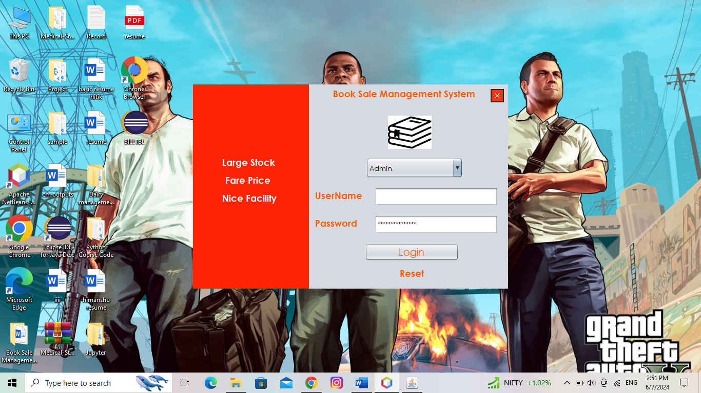**Login Page**

**INVALID USERNAME OR P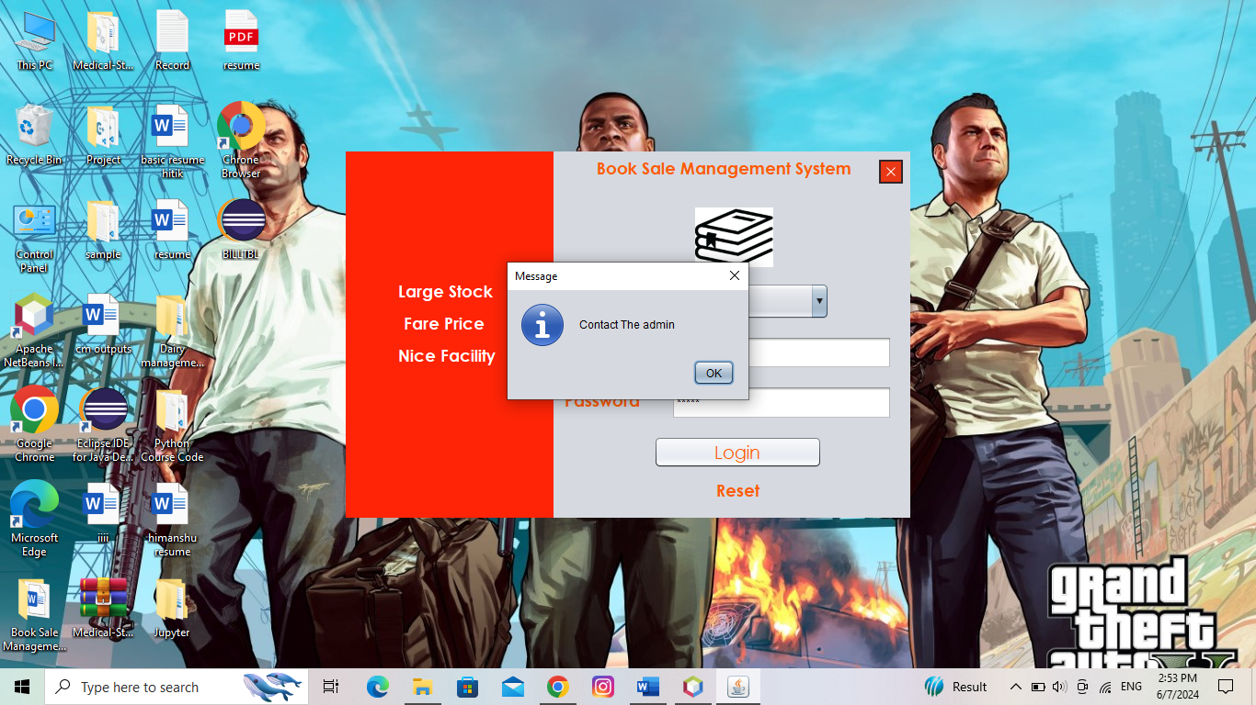ASSWORD**

**Admin Loging**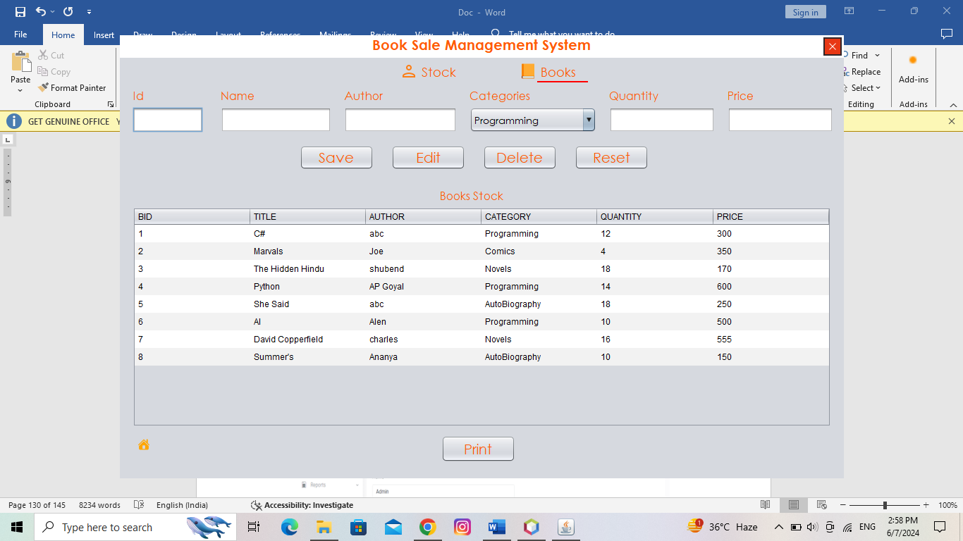

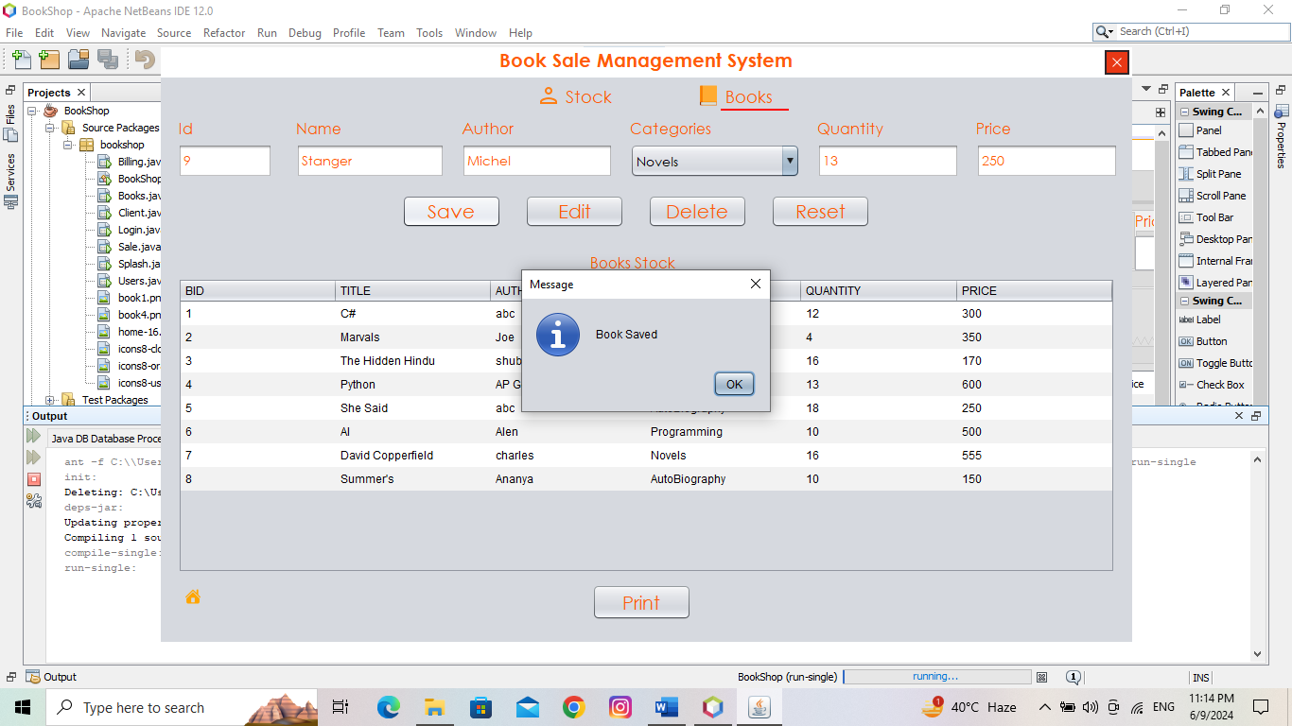**Add book**

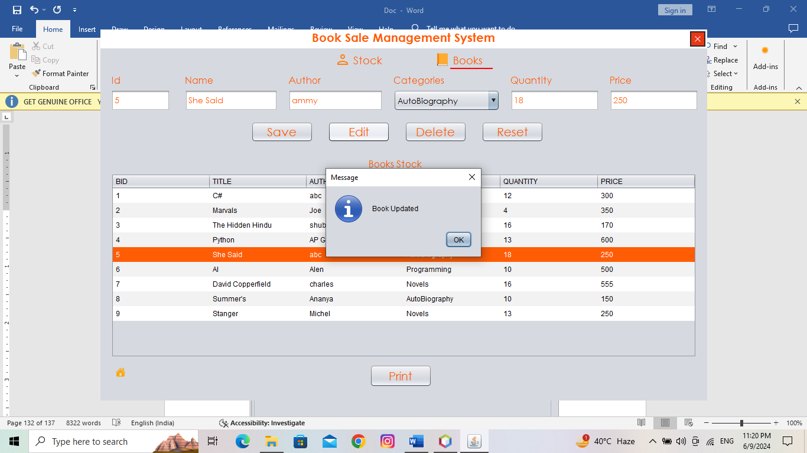**edit book**

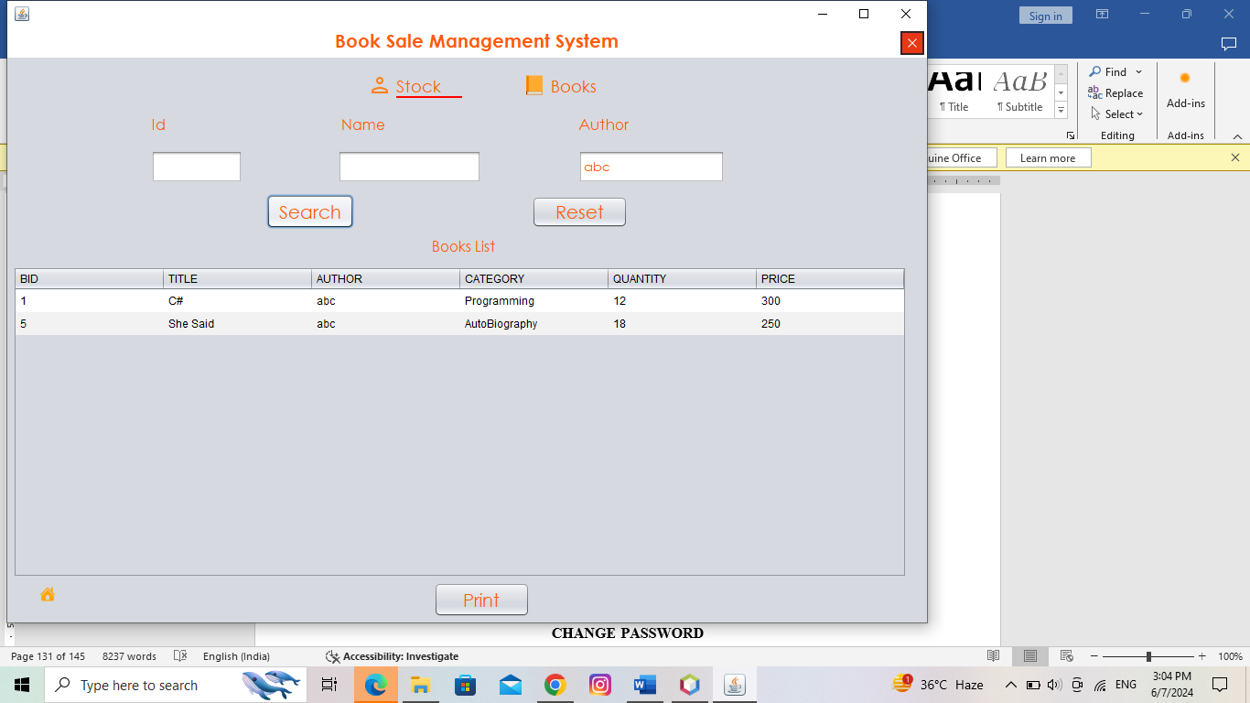**View stock**

**Seller Login**

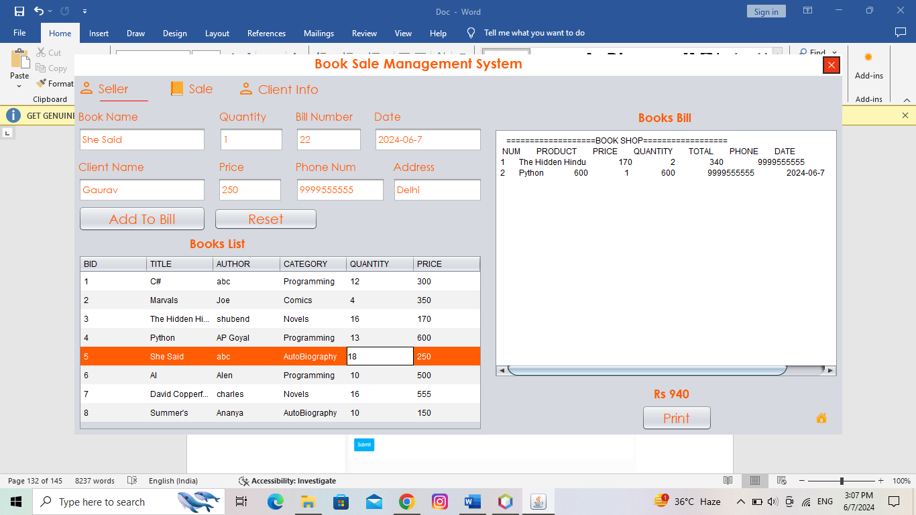**seller**

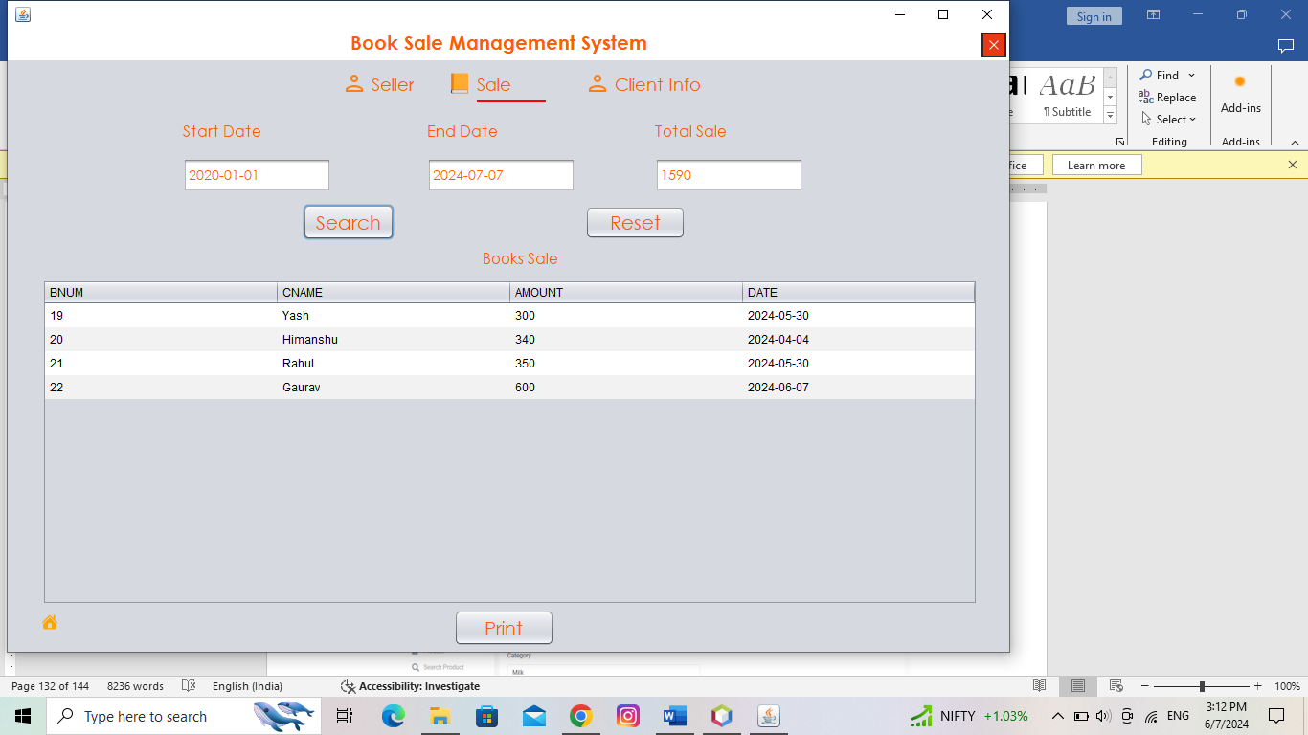**Total sale**

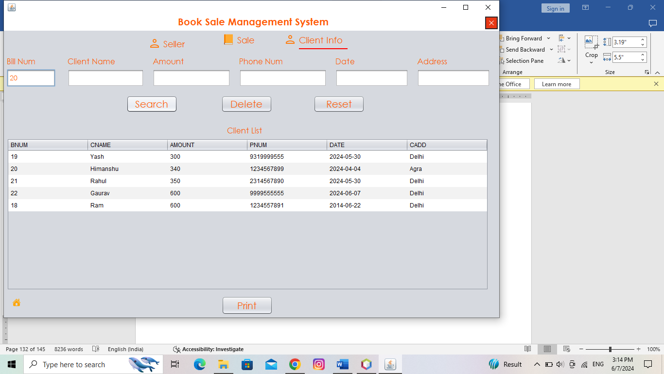**client information**

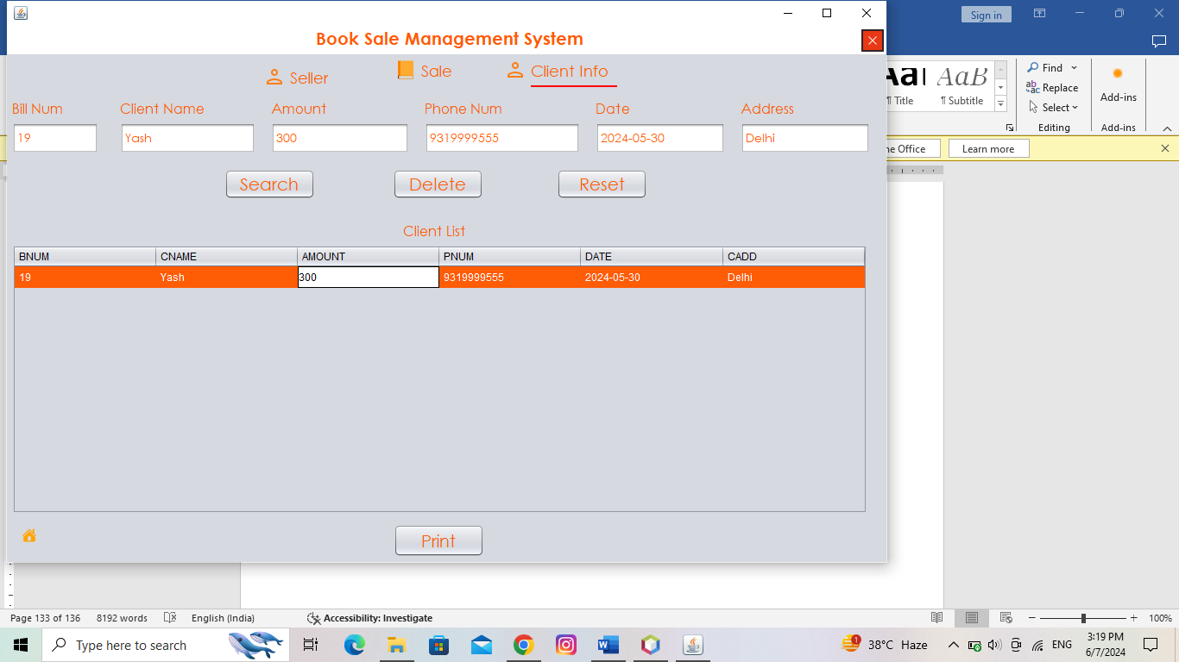

**LIMITATIONS**

#### 1. ****Complex Existing Code****

* **Description**: The current code is complicated, making it hard to understand and update without making mistakes.
* **Mitigation**: We will take small steps and review our changes carefully to avoid issues.

#### 2. ****Mixing Old and New Parts****

* **Description**: Adding new features to old parts of the application might cause problems because the old code might not be well-documented or easy to change.
* **Mitigation**: We will write clear instructions and keep the code organized to make integration easier.

#### 3. ****Limited Time and People****

* **Description**: We might not have enough time or team members to do everything we want.
* **Mitigation**: We will focus on the most important features and improvements first.

**Future application of the Project**

Improving the Java Swing application by updating and optimizing the forms and codebase sets the stage for several future applications and advancements. Here are some potential future applications of the project:

#### 1. ****Enhanced User Experience****

* **Description**: The improved UI and standardized forms will provide a more intuitive and user-friendly experience, leading to higher user satisfaction and engagement.
* **Application**: This can attract more users and potentially increase the application's adoption rate.

#### 2. ****Modular and Scalable Architecture****

* **Description**: Refactoring the codebase and improving form consistency can lead to a more modular and scalable architecture.
* **Application**: This allows for easier addition of new features and functionalities in the future without disrupting existing components.

#### 3. ****Cross-Platform Compatibility****

* **Description**: Ensuring compatibility with various operating systems and Java versions makes the application more versatile.
* **Application**: The application can be deployed across different environments, increasing its reach and usability.

**Bibliography**

**For java**

* <https://www.java.com/>
* <https://www.w3schools.com/java/>
* <https://www.geeksforgeeks.org/java/>

**For MySQL**

* <https://www.mysql.com/>
* [http://www.mysqltutorial.org](http://www.mysqltutorial.org/)